**V506 Homework Exercise 7**

**Authors: Jivitesh Poojary and Qiwen Zhu**

1. Answer:

TITLE "V506 HOMEWORK07 - JIVITESH POOJARY AND QIWEN ZHU";

**DATA** V506.Ttemp;

SET v506.Transport;

**RUN**;

**PROC** **REG**;

MODEL TPT = DISTCBD NUMAUTO /STB VIF;

**RUN**;

|  |
| --- |
| **V506 HOMEWORK07 - JIVITESH POOJARY AND QIWEN ZHU** |

**The REG Procedure**

**Model: MODEL1**

**Dependent Variable: TPT TPT**

|  |  |
| --- | --- |
| **Number of Observations Read** | 11 |
| **Number of Observations Used** | 11 |

| **Analysis of Variance** | | | | | |
| --- | --- | --- | --- | --- | --- |
| **Source** | **DF** | **Sum of Squares** | **Mean Square** | **F Value** | **Pr > F** |
| **Model** | 2 | 344226 | 172113 | 110.32 | <.0001 |
| **Error** | 8 | 12481 | 1560.09519 |  |  |
| **Corrected Total** | 10 | 356707 |  |  |  |

|  |  |  |  |
| --- | --- | --- | --- |
| **Root MSE** | 39.49804 | **R-Square** | 0.9650 |
| **Dependent Mean** | 270.63636 | **Adj R-Sq** | 0.9563 |
| **Coeff Var** | 14.59451 |  |  |

| **Parameter Estimates** | | | | | | | | |
| --- | --- | --- | --- | --- | --- | --- | --- | --- |
| **Variable** | **Label** | **DF** | **Parameter Estimate** | **Standard Error** | **t Value** | **Pr > |t|** | **Standardized Estimate** | **Variance Inflation** |
| **Intercept** | Intercept | 1 | 51.60107 | 52.38980 | 0.98 | 0.3535 | 0 | 0 |
| **DISTCBD** | DISTCBD | 1 | -10.12237 | 5.97582 | -1.69 | 0.1287 | -0.14077 | 1.57907 |
| **NUMAUTO** | NUMAUTO | 1 | 7.14910 | 0.66703 | 10.72 | <.0001 | 0.89070 | 1.57907 |

a) Β1 = 51.60107 Β2 = -10.12237 Β3 = 7.14910

Equation:

Total Person Trips (1000s) = 51.60107 - 10.12237(Linear Dist to CBD) + 7.14910(No. of Autos Owned) + u

b)

** =** 0.9563 => ~ 95.6% of the variation in the dependent variable

is explained by the independent variables

R2 can be very useful in the context of evaluating the strength of relationship or “goodness of fit” of a multivariate regression, it has an annoying property which makes it difficult to use in comparing different regression models with the same dependent variable.

* This property is that the value of R2 is partly dependent on the number of independent variables in the equation, regardless of their explanatory power. Hence, the value of R2 has the tendency to increase automatically as additional independent X variables are added to the model, thus erroneously indicating an increase in the explanatory power of the equation.
* This problem can be overcome by adjusting for the number of independent variables in the calculation of R2. Thus we obtain Adjusted R2.



c) Calculated F from the table is 8.65 while the one obtained from SAS after execution is 110.32. As this value is more than the calculated value we can say that we can reject the null hypothesis. (***H*0: *β*2 = *β*3 = 0)**

d) Plot: from the graph below there doesn’t seem to be any pattern,

|  |
| --- |
| **V506 HOMEWORK07 - JIVITESH POOJARY AND QIWEN ZHU** |

**The REG Procedure**

**Model: MODEL1**

**Dependent Variable: TPT TPT**

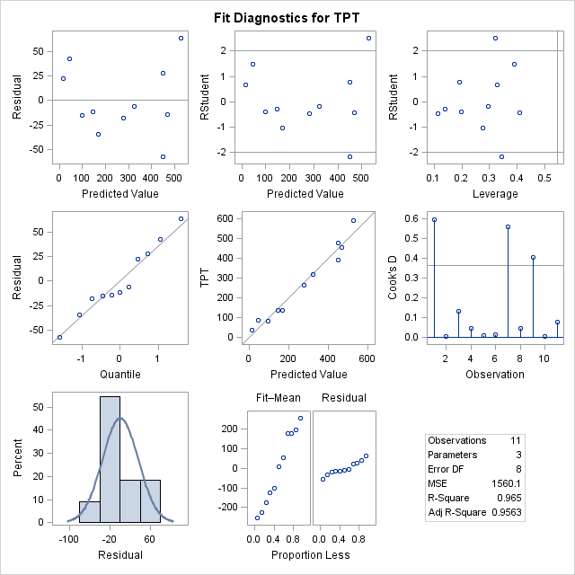

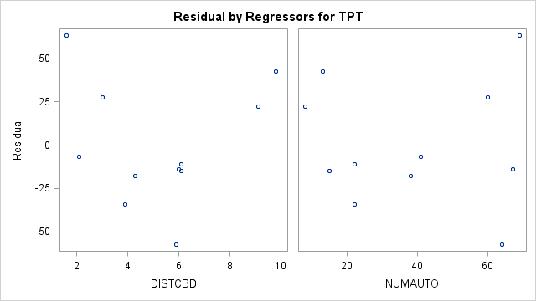

e) We use the following equation:

Total Person Trips (1000s) = 51.60107 - 10.12237(Linear Dist to CBD) + 7.14910(No. of Autos Owned) + u

- For zone 9 if the road trips were increased from 13000 to 18000 we would get Total Person trip value to be**: 81.08563707**

- If a new zone was 12.2 miles from the CBD and contained 28 thousand owned autos. The Total Person trip value to be**: 128.2829567**

There is degree of uncertainty with these values, as the standard error of the intercept is very high. The results obtained to be considered along with this fact.

f) We use the following equation:

Total Person Trips (1000s) = 51.60107 - 10.12237(Linear Dist to CBD) + 7.14910(No. of Autos Owned) + u

For a new zone that was 58.4 miles from CBD and contained 28000 owned autos, then the Total Person trip value to be**: 3035.005324**

This value seems to be highly unreliable as the value is much larger than the available data for us and there is degree of uncertainty with these values, as the standard error of the intercept is very high. The results obtained to be considered along with this fact.

1. Answer:

TITLE "V506 HOMEWORK07 - JIVITESH POOJARY AND QIWEN ZHU";

**DATA** V506.REtemp;

SET v506.REALEST;

**RUN**;

**PROC** **REG**;

MODEL PRICE = BEDROOMS SIZE DISTANCE BATHS GARAGE POOL;

**RUN**;

**PROC** **REG**;

MODEL PRICE = BEDROOMS SIZE BATHS GARAGE POOL;

**RUN**;

**PROC** **CORR**;

VAR PRICE BEDROOMS SIZE DISTANCE BATHS GARAGE POOL;

**RUN**;

|  |
| --- |
| 1. **V506 HOMEWORK07 - JIVITESH POOJARY AND QIWEN ZHU** |

**The REG Procedure**

**Model: MODEL1**

**Dependent Variable: Price Price**

|  |  |
| --- | --- |
| **Number of Observations Read** | 105 |
| **Number of Observations Used** | 105 |

| **Analysis of Variance** | | | | | |
| --- | --- | --- | --- | --- | --- |
| **Source** | **DF** | **Sum of Squares** | **Mean Square** | **F Value** | **Pr > F** |
| **Model** | 6 | 122561 | 20427 | 18.49 | <.0001 |
| **Error** | 98 | 108251 | 1104.60131 |  |  |
| **Corrected Total** | 104 | 230812 |  |  |  |

|  |  |  |  |
| --- | --- | --- | --- |
| **Root MSE** | 33.23554 | **R-Square** | 0.5310 |
| **Dependent Mean** | 221.10056 | **Adj R-Sq** | 0.5023 |
| **Coeff Var** | 15.03187 |  |  |

| **Parameter Estimates** | | | | | | |
| --- | --- | --- | --- | --- | --- | --- |
| **Variable** | **Label** | **DF** | **Parameter Estimate** | **Standard Error** | **t Value** | **Pr > |t|** |
| **Intercept** | Intercept | 1 | 57.95926 | 39.98828 | 1.45 | 0.1504 |
| **Bedrooms** | Bedrooms | 1 | 7.08930 | 2.56304 | 2.77 | 0.0068 |
| **Size** | Size | 1 | 0.03770 | 0.01472 | 2.56 | 0.0120 |
| **Distance** | Distance | 1 | -0.90178 | 0.72919 | -1.24 | 0.2192 |
| **Baths** | Baths | 1 | 22.92175 | 9.01357 | 2.54 | 0.0126 |
| **Garage** | Garage | 1 | 35.86134 | 7.64402 | 4.69 | <.0001 |
| **Pool** | Pool | 1 | -18.46616 | 6.99592 | -2.64 | 0.0097 |

A) Price = 57.95926 + 7.08930 (Bedrooms) + 0.03770 (Size) + -0.90178 (Distance) + 22.92175 (Baths) + 35.86134 (Garage) + -18.46616 (Pool)

With an increase in the values given in the Parameter estimate column of the table we observe that there is a unit increase in the Price considering all other variables are constant at that time.

* Distance and pool have a negative coefficient and thus decrease the price of the house. Distance is inversely related, as expected, and there does not seem to be a problem with correlation among the independent variables.
* As the distance increase the more the person has to travel, similarly if the pools are more the maintenance cost also rises.

B) Intercept value is: **57.95926**

|  |
| --- |
| **V506 HOMEWORK07 - JIVITESH POOJARY AND QIWEN ZHU** |

**The REG Procedure**

**Model: MODEL1**

**Dependent Variable: Price Price**

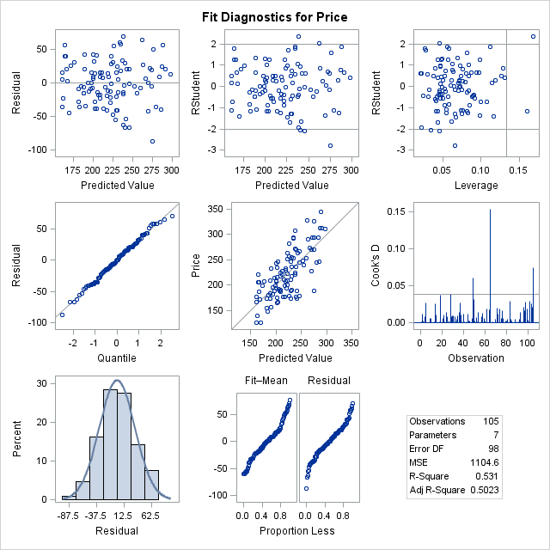

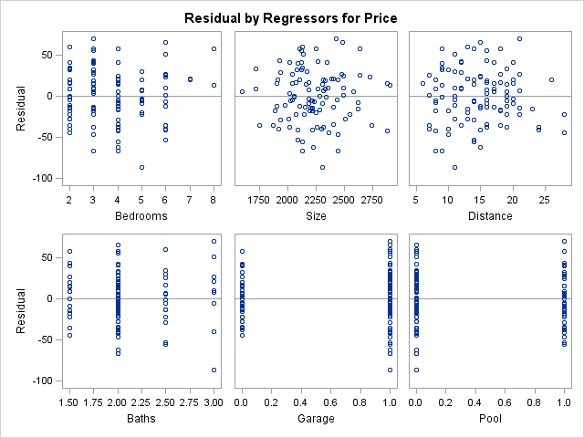

C) Correlation Matrix: All of the correlations are weak or medium. Form the values we can say that there will not be any problem of multicollinearity .

|  |
| --- |
| **V506 HOMEWORK07 - JIVITESH POOJARY AND QIWEN ZHU** |

**The CORR Procedure**

|  |  |
| --- | --- |
| **6 Variables:** | Bedrooms Size Distance Baths Garage Pool |

| **Simple Statistics** | | | | | | | |
| --- | --- | --- | --- | --- | --- | --- | --- |
| **Variable** | **N** | **Mean** | **Std Dev** | **Sum** | **Minimum** | **Maximum** | **Label** |
| **Bedrooms** | 105 | 3.80000 | 1.50256 | 399.00000 | 2.00000 | 8.00000 | Bedrooms |
| **Size** | 105 | 2231 | 249.31510 | 234298 | 1593 | 2908 | Size |
| **Distance** | 105 | 14.62857 | 4.87390 | 1536 | 6.00000 | 28.00000 | Distance |
| **Baths** | 105 | 2.08095 | 0.39299 | 218.50000 | 1.50000 | 3.00000 | Baths |
| **Garage** | 105 | 0.67619 | 0.47017 | 71.00000 | 0 | 1.00000 | Garage |
| **Pool** | 105 | 0.36190 | 0.48286 | 38.00000 | 0 | 1.00000 | Pool |

| **Pearson Correlation Coefficients, N = 105  Prob > |r| under H0: Rho=0** | | | | | | |
| --- | --- | --- | --- | --- | --- | --- |
|  | **Bedrooms** | **Size** | **Distance** | **Baths** | **Garage** | **Pool** |
| |  | | --- | | **Bedrooms** | | Bedrooms | | |  | | --- | | 1.00000 | |  | | |  | | --- | | 0.39795 | | <.0001 | | |  | | --- | | -0.15336 | | 0.1183 | | |  | | --- | | 0.32893 | | 0.0006 | | |  | | --- | | 0.23410 | | 0.0162 | | |  | | --- | | -0.00530 | | 0.9572 | |
| |  | | --- | | **Size** | | Size | | |  | | --- | | 0.39795 | | <.0001 | | |  | | --- | | 1.00000 | |  | | |  | | --- | | -0.13402 | | 0.1729 | | |  | | --- | | 0.04443 | | 0.6526 | | |  | | --- | | 0.09017 | | 0.3603 | | |  | | --- | | -0.19697 | | 0.0440 | |
| |  | | --- | | **Distance** | | Distance | | |  | | --- | | -0.15336 | | 0.1183 | | |  | | --- | | -0.13402 | | 0.1729 | | |  | | --- | | 1.00000 | |  | | |  | | --- | | -0.19499 | | 0.0462 | | |  | | --- | | -0.35929 | | 0.0002 | | |  | | --- | | 0.13938 | | 0.1562 | |
| |  | | --- | | **Baths** | | Baths | | |  | | --- | | 0.32893 | | 0.0006 | | |  | | --- | | 0.04443 | | 0.6526 | | |  | | --- | | -0.19499 | | 0.0462 | | |  | | --- | | 1.00000 | |  | | |  | | --- | | 0.22129 | | 0.0233 | | |  | | --- | | -0.05453 | | 0.5806 | |
| |  | | --- | | **Garage** | | Garage | | |  | | --- | | 0.23410 | | 0.0162 | | |  | | --- | | 0.09017 | | 0.3603 | | |  | | --- | | -0.35929 | | 0.0002 | | |  | | --- | | 0.22129 | | 0.0233 | | |  | | --- | | 1.00000 | |  | | |  | | --- | | -0.11415 | | 0.2462 | |
| |  | | --- | | **Pool** | | Pool | | |  | | --- | | -0.00530 | | 0.9572 | | |  | | --- | | -0.19697 | | 0.0440 | | |  | | --- | | 0.13938 | | 0.1562 | | |  | | --- | | -0.05453 | | 0.5806 | | |  | | --- | | -0.11415 | | 0.2462 | | |  | | --- | | 1.00000 | |  | |

D) From the above values we can see that we can reject the null hypothesis (***H*0: *β*2 = *β*3 = 0).** The results of the global test suggest that some of the independent variables have net regression coefficients different from zero.

F) We can see that Distance is an insignificant feature and hence we run the regression after removing it.

|  |
| --- |
| **V506 HOMEWORK07 - JIVITESH POOJARY AND QIWEN ZHU** |

**The REG Procedure**

**Model: MODEL1**

**Dependent Variable: Price Price**

|  |  |
| --- | --- |
| **Number of Observations Read** | 105 |
| **Number of Observations Used** | 105 |

| **Analysis of Variance** | | | | | |
| --- | --- | --- | --- | --- | --- |
| **Source** | **DF** | **Sum of Squares** | **Mean Square** | **F Value** | **Pr > F** |
| **Model** | 5 | 120872 | 24174 | 21.77 | <.0001 |
| **Error** | 99 | 109940 | 1110.50796 |  |  |
| **Corrected Total** | 104 | 230812 |  |  |  |

|  |  |  |  |
| --- | --- | --- | --- |
| **Root MSE** | 33.32428 | **R-Square** | 0.5237 |
| **Dependent Mean** | 221.10056 | **Adj R-Sq** | 0.4996 |
| **Coeff Var** | 15.07200 |  |  |

| **Parameter Estimates** | | | | | | |
| --- | --- | --- | --- | --- | --- | --- |
| **Variable** | **Label** | **DF** | **Parameter Estimate** | **Standard Error** | **t Value** | **Pr > |t|** |
| **Intercept** | Intercept | 1 | 37.10448 | 36.35541 | 1.02 | 0.3099 |
| **Bedrooms** | Bedrooms | 1 | 7.11692 | 2.56979 | 2.77 | 0.0067 |
| **Size** | Size | 1 | 0.03913 | 0.01472 | 2.66 | 0.0092 |
| **Baths** | Baths | 1 | 24.19785 | 8.97822 | 2.70 | 0.0083 |
| **Garage** | Garage | 1 | 38.80860 | 7.28241 | 5.33 | <.0001 |
| **Pool** | Pool | 1 | -19.20538 | 6.98895 | -2.75 | 0.0071 |

|  |
| --- |
| **V506 HOMEWORK07 - JIVITESH POOJARY AND QIWEN ZHU** |

**The REG Procedure**

**Model: MODEL1**

**Dependent Variable: Price Price**

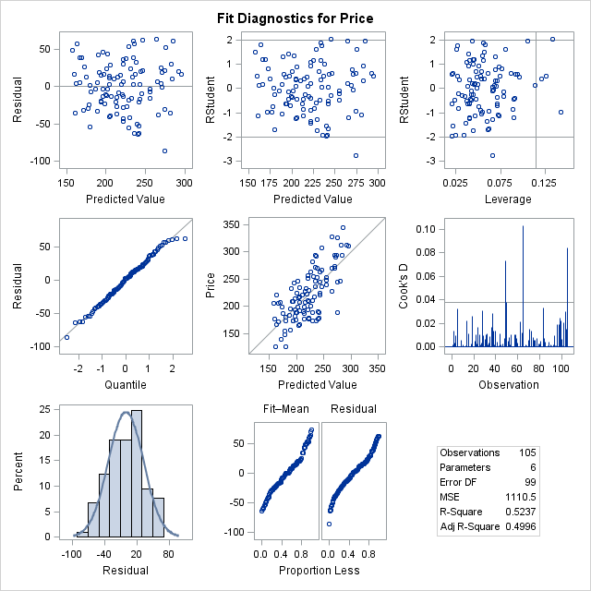

G) To some extent the plot looks to be normal, it is not completely normal as there are few peaks which do not follow normal distribution.

H) Plot is highlighted above.

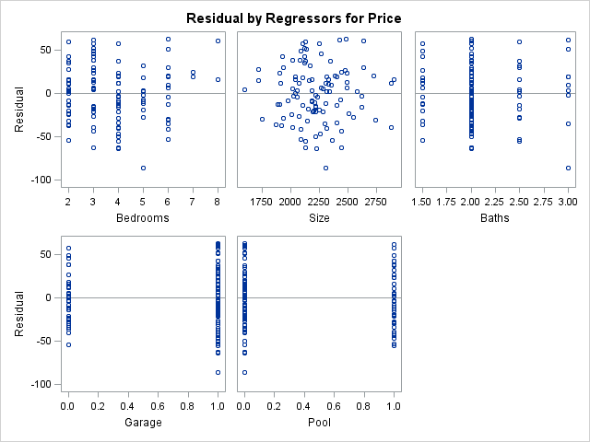

1. Answer:

TITLE "V506 HOMEWORK07 - JIVITESH POOJARY AND QIWEN ZHU";

**DATA** V506.BBtemp;

SET v506.BASEBALL2009;

**RUN**;

**PROC** **REG**;

MODEL WINS = BA SB ERRORS ERA HR LEAGUE;

**RUN**;

**PROC** **REG**;

MODEL WINS = BA ERRORS ERA HR LEAGUE;

**RUN**;

**PROC** **REG**;

MODEL WINS = BA ERRORS ERA HR;

**RUN**;

**PROC** **CORR**;

VAR WINS BA SB ERRORS ERA HR LEAGUE;

**RUN**;

|  |
| --- |
| **V506 HOMEWORK07 - JIVITESH POOJARY AND QIWEN ZHU** |

**The REG Procedure**

**Model: MODEL1**

**Dependent Variable: Wins**

|  |  |
| --- | --- |
| **Number of Observations Read** | 30 |
| **Number of Observations Used** | 30 |

| **Analysis of Variance** | | | | | |
| --- | --- | --- | --- | --- | --- |
| **Source** | **DF** | **Sum of Squares** | **Mean Square** | **F Value** | **Pr > F** |
| **Model** | 6 | 3305.50737 | 550.91790 | 26.05 | <.0001 |
| **Error** | 23 | 486.49263 | 21.15185 |  |  |
| **Corrected Total** | 29 | 3792.00000 |  |  |  |

|  |  |  |  |
| --- | --- | --- | --- |
| **Root MSE** | 4.59911 | **R-Square** | 0.8717 |
| **Dependent Mean** | 81.00000 | **Adj R-Sq** | 0.8382 |
| **Coeff Var** | 5.67792 |  |  |

| **Parameter Estimates** | | | | | |
| --- | --- | --- | --- | --- | --- |
| **Variable** | **DF** | **Parameter Estimate** | **Standard Error** | **t Value** | **Pr > |t|** |
| **Intercept** | 1 | 11.46434 | 31.49339 | 0.36 | 0.7192 |
| **BA** | 1 | 467.96139 | 110.21752 | 4.25 | 0.0003 |
| **SB** | 1 | 0.02658 | 0.03036 | 0.88 | 0.3903 |
| **Errors** | 1 | -0.09627 | 0.05830 | -1.65 | 0.1123 |
| **ERA** | 1 | -16.71343 | 2.13553 | -7.83 | <.0001 |
| **HR** | 1 | 0.15832 | 0.02925 | 5.41 | <.0001 |
| **League** | 1 | -2.56934 | 2.14985 | -1.20 | 0.2442 |

As we can, if all other variables are kept constant with an increase in the variable there is a unit change in the Win rate.

B) The coefficient of determination is R2 the value is **0.8717** and the adjusted value is **0.8382**.

C) Correlation Matrix:

|  |
| --- |
| **V506 HOMEWORK07 - JIVITESH POOJARY AND QIWEN ZHU** |

**The CORR Procedure**

|  |  |
| --- | --- |
| **7 Variables:** | Wins BA SB Errors ERA HR League |

| **Simple Statistics** | | | | | | |
| --- | --- | --- | --- | --- | --- | --- |
| **Variable** | **N** | **Mean** | **Std Dev** | **Sum** | **Minimum** | **Maximum** |
| **Wins** | 30 | 81.00000 | 11.43497 | 2430 | 59.00000 | 103.00000 |
| **BA** | 30 | 0.26233 | 0.00903 | 7.87000 | 0.24200 | 0.28500 |
| **SB** | 30 | 99.00000 | 30.70325 | 2970 | 56.00000 | 194.00000 |
| **Errors** | 30 | 95.20000 | 15.59487 | 2856 | 73.00000 | 143.00000 |
| **ERA** | 30 | 4.31400 | 0.43127 | 129.42000 | 3.41000 | 5.15000 |
| **HR** | 30 | 168.06667 | 33.07352 | 5042 | 95.00000 | 244.00000 |
| **League** | 30 | 0.46667 | 0.50742 | 14.00000 | 0 | 1.00000 |

| **Pearson Correlation Coefficients, N = 30  Prob > |r| under H0: Rho=0** | | | | | | | |
| --- | --- | --- | --- | --- | --- | --- | --- |
|  | **Wins** | **BA** | **SB** | **Errors** | **ERA** | **HR** | **League** |
| **Wins** | |  | | --- | | 1.00000 | |  | | |  | | --- | | 0.46720 | | 0.0092 | | |  | | --- | | 0.26685 | | 0.1540 | | |  | | --- | | -0.40801 | | 0.0252 | | |  | | --- | | -0.63476 | | 0.0002 | | |  | | --- | | 0.51351 | | 0.0037 | | |  | | --- | | 0.07726 | | 0.6849 | |
| **BA** | |  | | --- | | 0.46720 | | 0.0092 | | |  | | --- | | 1.00000 | |  | | |  | | --- | | 0.26666 | | 0.1543 | | |  | | --- | | -0.26544 | | 0.1563 | | |  | | --- | | 0.06340 | | 0.7393 | | |  | | --- | | 0.29031 | | 0.1196 | | |  | | --- | | 0.43148 | | 0.0173 | |
| **SB** | |  | | --- | | 0.26685 | | 0.1540 | | |  | | --- | | 0.26666 | | 0.1543 | | |  | | --- | | 1.00000 | |  | | |  | | --- | | -0.09247 | | 0.6270 | | |  | | --- | | 0.00966 | | 0.9596 | | |  | | --- | | 0.28392 | | 0.1284 | | |  | | --- | | 0.34307 | | 0.0635 | |
| **Errors** | |  | | --- | | -0.40801 | | 0.0252 | | |  | | --- | | -0.26544 | | 0.1563 | | |  | | --- | | -0.09247 | | 0.6270 | | |  | | --- | | 1.00000 | |  | | |  | | --- | | 0.18081 | | 0.3390 | | |  | | --- | | -0.13742 | | 0.4690 | | |  | | --- | | -0.04271 | | 0.8227 | |
| **ERA** | |  | | --- | | -0.63476 | | 0.0002 | | |  | | --- | | 0.06340 | | 0.7393 | | |  | | --- | | 0.00966 | | 0.9596 | | |  | | --- | | 0.18081 | | 0.3390 | | |  | | --- | | 1.00000 | |  | | |  | | --- | | 0.06579 | | 0.7298 | | |  | | --- | | 0.30633 | | 0.0997 | |
| **HR** | |  | | --- | | 0.51351 | | 0.0037 | | |  | | --- | | 0.29031 | | 0.1196 | | |  | | --- | | 0.28392 | | 0.1284 | | |  | | --- | | -0.13742 | | 0.4690 | | |  | | --- | | 0.06579 | | 0.7298 | | |  | | --- | | 1.00000 | |  | | |  | | --- | | 0.42547 | | 0.0191 | |
| **League** | |  | | --- | | 0.07726 | | 0.6849 | | |  | | --- | | 0.43148 | | 0.0173 | | |  | | --- | | 0.34307 | | 0.0635 | | |  | | --- | | -0.04271 | | 0.8227 | | |  | | --- | | 0.30633 | | 0.0997 | | |  | | --- | | 0.42547 | | 0.0191 | | |  | | --- | | 1.00000 | |  | |

The highlighted value above show a greater degree of correlation.

D) The results of the global test suggest that some of the independent variables have net regression coefficients different from zero.

|  |
| --- |
| **V506 HOMEWORK07 - JIVITESH POOJARY AND QIWEN ZHU** |

**The REG Procedure**

**Model: MODEL1**

**Dependent Variable: Wins**

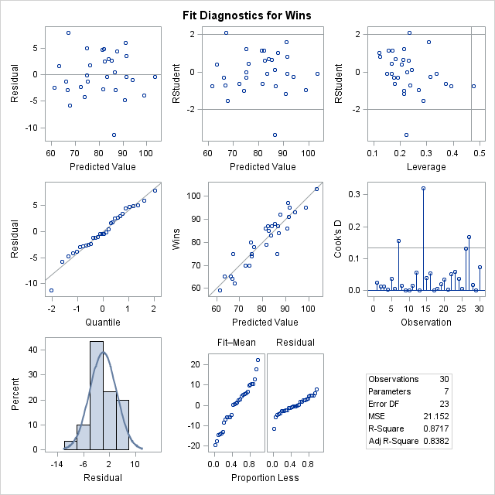

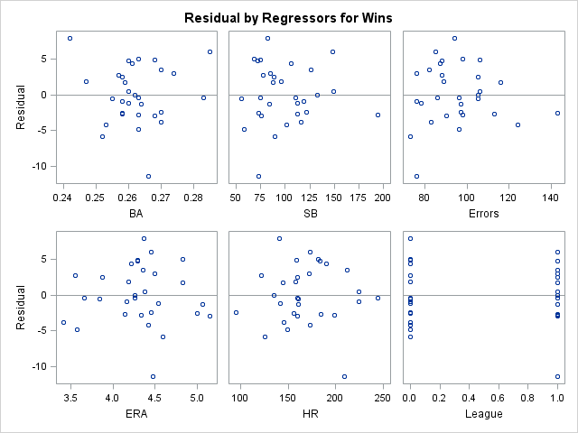

|  |
| --- |
| **V506 HOMEWORK07 - JIVITESH POOJARY AND QIWEN ZHU** |

**The REG Procedure**

**Model: MODEL1**

**Dependent Variable: Wins**

|  |  |
| --- | --- |
| **Number of Observations Read** | 30 |
| **Number of Observations Used** | 30 |

| **Analysis of Variance** | | | | | |
| --- | --- | --- | --- | --- | --- |
| **Source** | **DF** | **Sum of Squares** | **Mean Square** | **F Value** | **Pr > F** |
| **Model** | 5 | 3289.29173 | 657.85835 | 31.41 | <.0001 |
| **Error** | 24 | 502.70827 | 20.94618 |  |  |
| **Corrected Total** | 29 | 3792.00000 |  |  |  |

|  |  |  |  |
| --- | --- | --- | --- |
| **Root MSE** | 4.57670 | **R-Square** | 0.8674 |
| **Dependent Mean** | 81.00000 | **Adj R-Sq** | 0.8398 |
| **Coeff Var** | 5.65025 |  |  |

| **Parameter Estimates** | | | | | |
| --- | --- | --- | --- | --- | --- |
| **Variable** | **DF** | **Parameter Estimate** | **Standard Error** | **t Value** | **Pr > |t|** |
| **Intercept** | 1 | 11.33609 | 31.33956 | 0.36 | 0.7207 |
| **BA** | 1 | 478.34579 | 109.04349 | 4.39 | 0.0002 |
| **Errors** | 1 | -0.09711 | 0.05800 | -1.67 | 0.1071 |
| **ERA** | 1 | -16.87018 | 2.11764 | -7.97 | <.0001 |
| **HR** | 1 | 0.16188 | 0.02882 | 5.62 | <.0001 |
| **League** | 1 | -2.15655 | 2.08729 | -1.03 | 0.3118 |

|  |
| --- |
| **V506 HOMEWORK07 - JIVITESH POOJARY AND QIWEN ZHU** |

**The REG Procedure**

**Model: MODEL1**

**Dependent Variable: Wins**

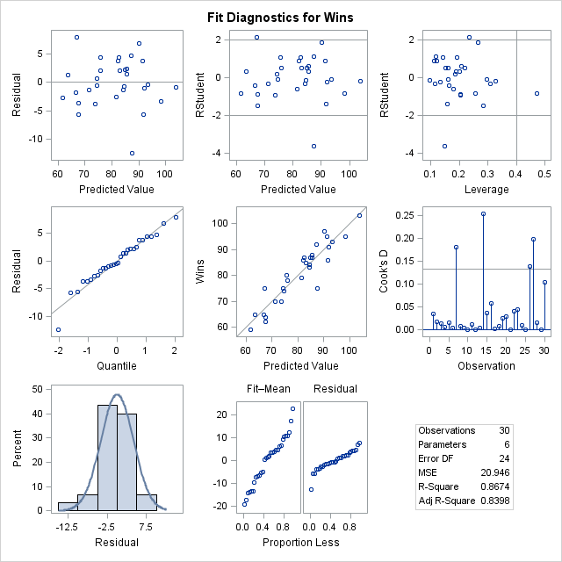

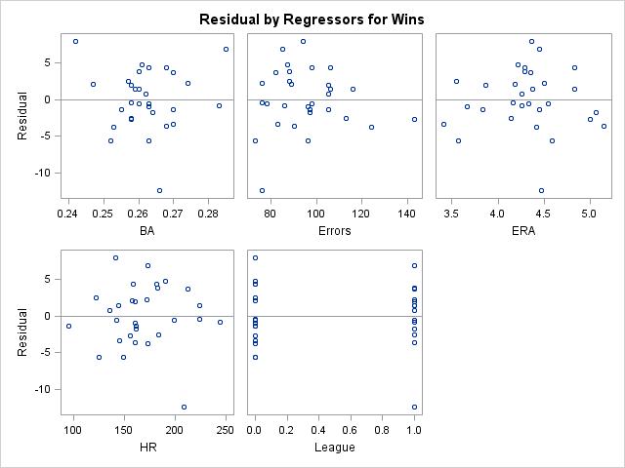

|  |
| --- |
| **V506 HOMEWORK07 - JIVITESH POOJARY AND QIWEN ZHU** |

**The REG Procedure**

**Model: MODEL1**

**Dependent Variable: Wins**

|  |  |
| --- | --- |
| **Number of Observations Read** | 30 |
| **Number of Observations Used** | 30 |

| **Analysis of Variance** | | | | | |
| --- | --- | --- | --- | --- | --- |
| **Source** | **DF** | **Sum of Squares** | **Mean Square** | **F Value** | **Pr > F** |
| **Model** | 4 | 3266.93252 | 816.73313 | 38.89 | <.0001 |
| **Error** | 25 | 525.06748 | 21.00270 |  |  |
| **Corrected Total** | 29 | 3792.00000 |  |  |  |

|  |  |  |  |
| --- | --- | --- | --- |
| **Root MSE** | 4.58287 | **R-Square** | 0.8615 |
| **Dependent Mean** | 81.00000 | **Adj R-Sq** | 0.8394 |
| **Coeff Var** | 5.65786 |  |  |

| **Parameter Estimates** | | | | | |
| --- | --- | --- | --- | --- | --- |
| **Variable** | **DF** | **Parameter Estimate** | **Standard Error** | **t Value** | **Pr > |t|** |
| **Intercept** | 1 | 25.82736 | 28.06353 | 0.92 | 0.3662 |
| **BA** | 1 | 437.80055 | 101.87437 | 4.30 | 0.0002 |
| **Errors** | 1 | -0.10016 | 0.05801 | -1.73 | 0.0966 |
| **ERA** | 1 | -17.52074 | 2.02458 | -8.65 | <.0001 |
| **HR** | 1 | 0.15138 | 0.02700 | 5.61 | <.0001 |

|  |
| --- |
| **V506 HOMEWORK07 - JIVITESH POOJARY AND QIWEN ZHU** |

**The REG Procedure**

**Model: MODEL1**

**Dependent Variable: Wins**

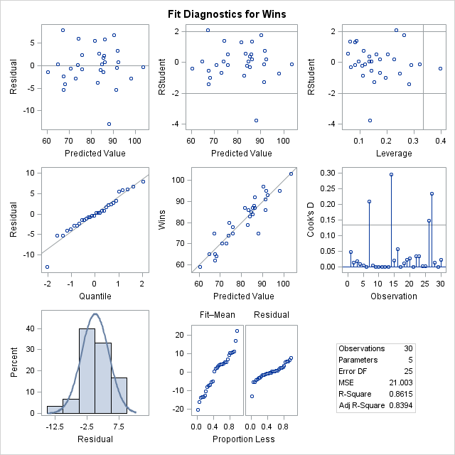

G) To some extent the plot looks to be normal, it is not completely normal as there are few peaks which do not follow normal distribution.

H) Plot is highlighted above.

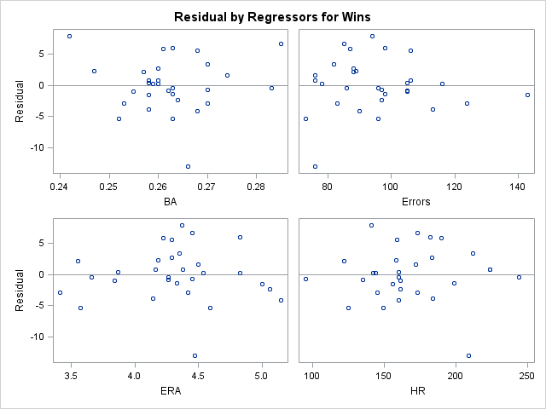

1. Answer:

TITLE "V506 HOMEWORK07 - JIVITESH POOJARY AND QIWEN ZHU";

**DATA** V506.WCtemp;

SET v506.WILDCATS;

**RUN**;

**PROC** **REG**;

MODEL WILDCATS = PRICE OUTPUT GNP TIME/STB VIF;

**RUN**;

**PROC** **REG**;

MODEL WILDCATS = PRICE OUTPUT GNP/STB VIF;

**RUN**;

**PROC** **CORR**;

VAR WILDCATS PRICE OUTPUT GNP TIME;

**RUN**;

|  |
| --- |
| **V506 HOMEWORK07 - JIVITESH POOJARY AND QIWEN ZHU** |

**The REG Procedure**

**Model: MODEL1**

**Dependent Variable: WILDCATS WILDCATS**

|  |  |
| --- | --- |
| **Number of Observations Read** | 31 |
| **Number of Observations Used** | 31 |

| **Analysis of Variance** | | | | | |
| --- | --- | --- | --- | --- | --- |
| **Source** | **DF** | **Sum of Squares** | **Mean Square** | **F Value** | **Pr > F** |
| **Model** | 4 | 96.27243 | 24.06811 | 8.92 | 0.0001 |
| **Error** | 26 | 70.17616 | 2.69908 |  |  |
| **Corrected Total** | 30 | 166.44859 |  |  |  |

|  |  |  |  |
| --- | --- | --- | --- |
| **Root MSE** | 1.64289 | **R-Square** | 0.5784 |
| **Dependent Mean** | 10.63742 | **Adj R-Sq** | 0.5135 |
| **Coeff Var** | 15.44443 |  |  |

| **Parameter Estimates** | | | | | | | | |
| --- | --- | --- | --- | --- | --- | --- | --- | --- |
| **Variable** | **Label** | **DF** | **Parameter Estimate** | **Standard Error** | **t Value** | **Pr > |t|** | **Standardized Estimate** | **Variance Inflation** |
| **Intercept** | Intercept | 1 | -9.79893 | 8.93125 | -1.10 | 0.2826 | 0 | 0 |
| **PRICE** | PRICE | 1 | 2.70018 | 0.69859 | 3.87 | 0.0007 | 0.93258 | 3.59004 |
| **OUTPUT** | OUTPUT | 1 | 3.04513 | 0.94111 | 3.24 | 0.0033 | 1.45678 | 12.50033 |
| **GNP** | GNP | 1 | -0.01599 | 0.00821 | -1.95 | 0.0623 | -1.84250 | 55.19159 |
| **TIME** | TIME | 1 | -0.02335 | 0.27341 | -0.09 | 0.9326 | -0.09012 | 68.68524 |

**WILDCATS = -9.79893 + 2.70018 (PRICE) + 3.04513 (OUTPUT) + -0.01599 (GNP) + -0.02335 (TIME)**

R2 = 0.5784

Adjusted R2 = 0.5135

|  |
| --- |
| **V506 HOMEWORK07 - JIVITESH POOJARY AND QIWEN ZHU** |

**The REG Procedure**

**Model: MODEL1**

**Dependent Variable: WILDCATS WILDCATS**

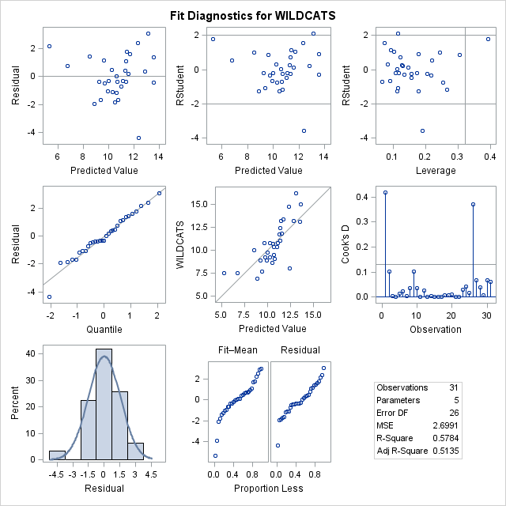

From the above plot we can see that the values are concentrated between the predicted values 8 to 12.

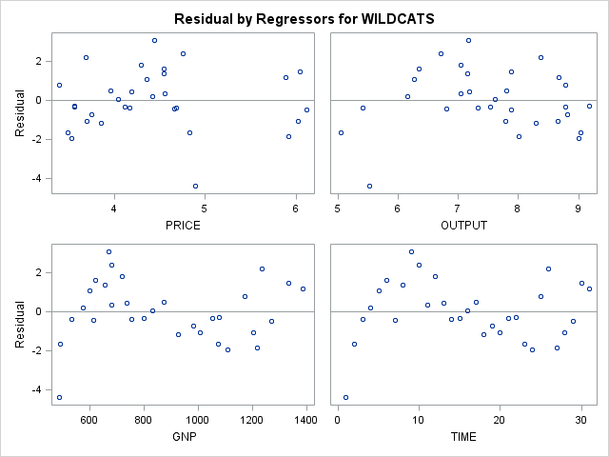

|  |
| --- |
| **V506 HOMEWORK07 - JIVITESH POOJARY AND QIWEN ZHU** |

**The REG Procedure**

**Model: MODEL1**

**Dependent Variable: WILDCATS WILDCATS**

|  |  |
| --- | --- |
| **Number of Observations Read** | 31 |
| **Number of Observations Used** | 31 |

| **Analysis of Variance** | | | | | |
| --- | --- | --- | --- | --- | --- |
| **Source** | **DF** | **Sum of Squares** | **Mean Square** | **F Value** | **Pr > F** |
| **Model** | 3 | 96.25275 | 32.08425 | 12.34 | <.0001 |
| **Error** | 27 | 70.19584 | 2.59985 |  |  |
| **Corrected Total** | 30 | 166.44859 |  |  |  |

|  |  |  |  |
| --- | --- | --- | --- |
| **Root MSE** | 1.61240 | **R-Square** | 0.5783 |
| **Dependent Mean** | 10.63742 | **Adj R-Sq** | 0.5314 |
| **Coeff Var** | 15.15785 |  |  |

| **Parameter Estimates** | | | | | | | | |
| --- | --- | --- | --- | --- | --- | --- | --- | --- |
| **Variable** | **Label** | **DF** | **Parameter Estimate** | **Standard Error** | **t Value** | **Pr > |t|** | **Standardized Estimate** | **Variance Inflation** |
| **Intercept** | Intercept | 1 | -9.25062 | 6.09269 | -1.52 | 0.1406 | 0 | 0 |
| **PRICE** | PRICE | 1 | 2.68158 | 0.65145 | 4.12 | 0.0003 | 0.92616 | 3.24104 |
| **OUTPUT** | OUTPUT | 1 | 3.00864 | 0.82290 | 3.66 | 0.0011 | 1.43932 | 9.92205 |
| **GNP** | GNP | 1 | -0.01663 | 0.00331 | -5.03 | <.0001 | -1.91617 | 9.30475 |

|  |
| --- |
| **V506 HOMEWORK07 - JIVITESH POOJARY AND QIWEN ZHU** |

**The REG Procedure**

**Model: MODEL1**

**Dependent Variable: WILDCATS WILDCATS**

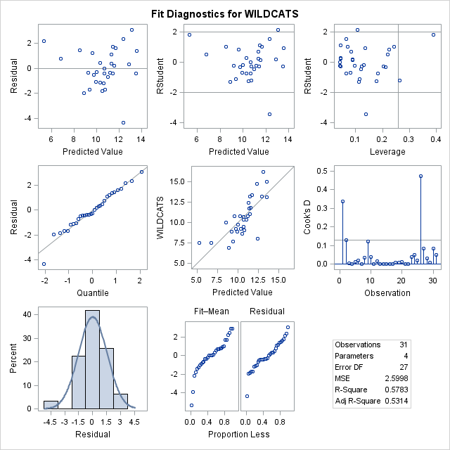

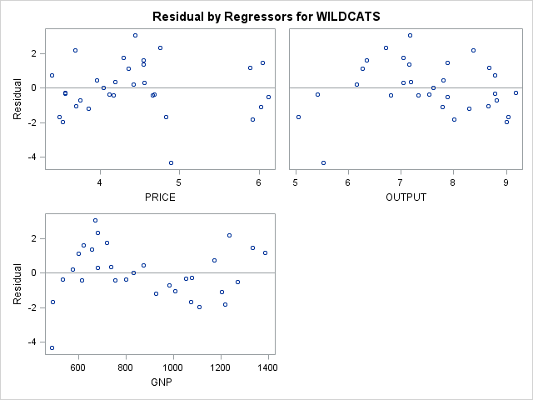

Correlation Matrix:

|  |
| --- |
| **V506 HOMEWORK07 - JIVITESH POOJARY AND QIWEN ZHU** |

**The CORR Procedure**

|  |  |
| --- | --- |
| **5 Variables:** | WILDCATS PRICE OUTPUT GNP TIME |

| **Simple Statistics** | | | | | | | |
| --- | --- | --- | --- | --- | --- | --- | --- |
| **Variable** | **N** | **Mean** | **Std Dev** | **Sum** | **Minimum** | **Maximum** | **Label** |
| **WILDCATS** | 31 | 10.63742 | 2.35548 | 329.76000 | 6.92000 | 16.17000 | WILDCATS |
| **PRICE** | 31 | 4.44968 | 0.81353 | 137.94000 | 3.39000 | 6.12000 | PRICE |
| **OUTPUT** | 31 | 7.52484 | 1.12685 | 233.27000 | 5.05000 | 9.18000 | OUTPUT |
| **GNP** | 31 | 882.78903 | 271.35395 | 27366 | 487.67000 | 1385 | GNP |
| **TIME** | 31 | 16.00000 | 9.09212 | 496.00000 | 1.00000 | 31.00000 | TIME |

| **Pearson Correlation Coefficients, N = 31  Prob > |r| under H0: Rho=0** | | | | | |
| --- | --- | --- | --- | --- | --- |
|  | **WILDCATS** | **PRICE** | **OUTPUT** | **GNP** | **TIME** |
| |  | | --- | | **WILDCATS** | | WILDCATS | | |  | | --- | | 1.00000 | |  | | |  | | --- | | 0.13778 | | 0.4598 | | |  | | --- | | -0.42851 | | 0.0162 | | |  | | --- | | -0.55706 | | 0.0011 | | |  | | --- | | -0.52983 | | 0.0022 | |
| |  | | --- | | **PRICE** | | PRICE | | |  | | --- | | 0.13778 | | 0.4598 | | |  | | --- | | 1.00000 | |  | | |  | | --- | | -0.30542 | | 0.0948 | | |  | | --- | | 0.18202 | | 0.3271 | | |  | | --- | | 0.16088 | | 0.3873 | |
| |  | | --- | | **OUTPUT** | | OUTPUT | | |  | | --- | | -0.42851 | | 0.0162 | | |  | | --- | | -0.30542 | | 0.0948 | | |  | | --- | | 1.00000 | |  | | |  | | --- | | 0.82715 | | <.0001 | | |  | | --- | | 0.84805 | | <.0001 | |
| |  | | --- | | **GNP** | | GNP | | |  | | --- | | -0.55706 | | 0.0011 | | |  | | --- | | 0.18202 | | 0.3271 | | |  | | --- | | 0.82715 | | <.0001 | | |  | | --- | | 1.00000 | |  | | |  | | --- | | 0.99059 | | <.0001 | |
| |  | | --- | | **TIME** | | TIME | | |  | | --- | | -0.52983 | | 0.0022 | | |  | | --- | | 0.16088 | | 0.3873 | | |  | | --- | | 0.84805 | | <.0001 | | |  | | --- | | 0.99059 | | <.0001 | | |  | | --- | | 1.00000 | |  | |

The highlighted attributes are highly correlated.

1. Answer:

SIMPLE MODEL WITHOUT INTERACTION AND NON-LINEAR VARIABLE TRANSFORMATION:

TITLE "V506 HOMEWORK07 - JIVITESH POOJARY AND QIWEN ZHU";

**PROC** **UNIVARIATE** DATA=V506.Gss_2;

VAR MAEDUC TVHOURS PARTYID SMOKE;

**RUN**;

**DATA** V506.Gtemp;

SET v506.Gss_2;

IF MAEDUC = **97** THEN MAEDUC =".";

IF MAEDUC = **98** THEN MAEDUC =".";

IF MAEDUC = **99** THEN MAEDUC =".";

IF TVHOURS = **98** THEN TVHOURS =".";

IF TVHOURS = **99** THEN TVHOURS =".";

IF PARTYID = **9** THEN PARTYID =".";

IF SMOKE = **1** THEN DSMOKE = **1**;

ELSE IF SMOKE =**2** THEN DSMOKE = **0**;

ELSE DSMOKE =".";

IF PARTYID = **0** THEN LEANDEM = **1**;

IF PARTYID = **1** THEN LEANDEM = **1**;

IF PARTYID = **2** THEN LEANDEM = **1**;

IF PARTYID = **3** THEN LEANDEM = **1**;

IF PARTYID = **4** THEN LEANDEM = **0**;

IF PARTYID = **5** THEN LEANDEM = **0**;

IF PARTYID = **6** THEN LEANDEM = **0**;

IF PARTYID = **3** THEN INDEP = **1**;

ELSE INDEP = **0**;

**RUN**;

**PROC** **UNIVARIATE** DATA=V506.GTemp;

VAR MAEDUC TVHOURS PARTYID SMOKE;

**RUN**;

**PROC** **REG**;

MODEL HEALTH = DSMOKE EDUC PAEDUC MAEDUC CLASS AGE HAPPY REALINC TVHOURS SEXFREQ PARTYID LEANDEM INDEP/STB VIF;

**RUN**;

**PROC** **REG**;

MODEL HEALTH = DSMOKE EDUC PAEDUC AGE HAPPY REALINC TVHOURS SEXFREQ INDEP/STB VIF;

**RUN**;

**PROC** **REG**;

MODEL HEALTH = DSMOKE EDUC PAEDUC HAPPY REALINC TVHOURS SEXFREQ INDEP/STB VIF;

**RUN**;

**PROC** **REG**;

MODEL HEALTH = DSMOKE EDUC PAEDUC HAPPY TVHOURS SEXFREQ INDEP/STB VIF;

**RUN**;

**PROC** **REG**;

MODEL HEALTH = DSMOKE EDUC HAPPY TVHOURS SEXFREQ INDEP/STB VIF;

**RUN**;

**PROC** **REG**;

MODEL HEALTH = DSMOKE EDUC HAPPY TVHOURS SEXFREQ/STB VIF;

**RUN**;

**PROC** **CORR**;

VAR HEALTH DSMOKE EDUC PAEDUC MAEDUC CLASS AGE HAPPY REALINC TVHOURS SEXFREQ PARTYID LEANDEM INDEP;

**RUN**;

|  |
| --- |
| 1. **V506 HOMEWORK07 - JIVITESH POOJARY AND QIWEN ZHU** |

**The UNIVARIATE Procedure**

**Variable: MAEDUC**

| **Moments** | | | |
| --- | --- | --- | --- |
| **N** | 4677 | **Sum Weights** | 4677 |
| **Mean** | 16.5967501 | **Sum Observations** | 77623 |
| **Std Deviation** | 20.9331366 | **Variance** | 438.196208 |
| **Skewness** | 3.50667337 | **Kurtosis** | 10.73916 |
| **Uncorrected SS** | 3337295 | **Corrected SS** | 2049005.47 |
| **Coeff Variation** | 126.127926 | **Std Error Mean** | 0.30609104 |

| **Basic Statistical Measures** | | | |
| --- | --- | --- | --- |
| **Location** | | **Variability** | |
| **Mean** | 16.59675 | **Std Deviation** | 20.93314 |
| **Median** | 12.00000 | **Variance** | 438.19621 |
| **Mode** | 12.00000 | **Range** | 99.00000 |
|  |  | **Interquartile Range** | 4.00000 |

| **Tests for Location: Mu0=0** | | | | |
| --- | --- | --- | --- | --- |
| **Test** | **Statistic** | | **p Value** | |
| **Student's t** | **t** | 54.22161 | **Pr > |t|** | <.0001 |
| **Sign** | **M** | 2301.5 | **Pr >= |M|** | <.0001 |
| **Signed Rank** | **S** | 5298053 | **Pr >= |S|** | <.0001 |

| **Quantiles (Definition 5)** | |
| --- | --- |
| **Level** | **Quantile** |
| **100% Max** | 99 |
| **99%** | 98 |
| **95%** | 97 |
| **90%** | 16 |
| **75% Q3** | 14 |
| **50% Median** | 12 |
| **25% Q1** | 10 |
| **10%** | 8 |
| **5%** | 6 |
| **1%** | 0 |
| **0% Min** | 0 |

| **Extreme Observations** | | | |
| --- | --- | --- | --- |
| **Lowest** | | **Highest** | |
| **Value** | **Obs** | **Value** | **Obs** |
| 0 | 4630 | 99 | 1749 |
| 0 | 4244 | 99 | 2309 |
| 0 | 4233 | 99 | 3637 |
| 0 | 4135 | 99 | 4046 |
| 0 | 3866 | 99 | 4461 |

|  |
| --- |
| **V506 HOMEWORK07 - JIVITESH POOJARY AND QIWEN ZHU** |

**The UNIVARIATE Procedure**

**Variable: TVHOURS**

| **Moments** | | | |
| --- | --- | --- | --- |
| **N** | 2807 | **Sum Weights** | 2807 |
| **Mean** | 3.16601354 | **Sum Observations** | 8887 |
| **Std Deviation** | 6.83823466 | **Variance** | 46.7614532 |
| **Skewness** | 12.777818 | **Kurtosis** | 175.633346 |
| **Uncorrected SS** | 159349 | **Corrected SS** | 131212.638 |
| **Coeff Variation** | 215.9888 | **Std Error Mean** | 0.12906925 |

| **Basic Statistical Measures** | | | |
| --- | --- | --- | --- |
| **Location** | | **Variability** | |
| **Mean** | 3.166014 | **Std Deviation** | 6.83823 |
| **Median** | 2.000000 | **Variance** | 46.76145 |
| **Mode** | 2.000000 | **Range** | 99.00000 |
|  |  | **Interquartile Range** | 3.00000 |

| **Tests for Location: Mu0=0** | | | | |
| --- | --- | --- | --- | --- |
| **Test** | **Statistic** | | **p Value** | |
| **Student's t** | **t** | 24.52957 | **Pr > |t|** | <.0001 |
| **Sign** | **M** | 1348 | **Pr >= |M|** | <.0001 |
| **Signed Rank** | **S** | 1817778 | **Pr >= |S|** | <.0001 |

| **Quantiles (Definition 5)** | |
| --- | --- |
| **Level** | **Quantile** |
| **100% Max** | 99 |
| **99%** | 12 |
| **95%** | 6 |
| **90%** | 5 |
| **75% Q3** | 4 |
| **50% Median** | 2 |
| **25% Q1** | 1 |
| **10%** | 1 |
| **5%** | 1 |
| **1%** | 0 |
| **0% Min** | 0 |

| **Extreme Observations** | | | |
| --- | --- | --- | --- |
| **Lowest** | | **Highest** | |
| **Value** | **Obs** | **Value** | **Obs** |
| 0 | 4676 | 99 | 1638 |
| 0 | 4674 | 99 | 1899 |
| 0 | 4671 | 99 | 2222 |
| 0 | 4650 | 99 | 3515 |
| 0 | 4643 | 99 | 3698 |

| **Missing Values** | | | |
| --- | --- | --- | --- |
| **Missing Value** | **Count** | **Percent Of** | |
| **All Obs** | **Missing Obs** |
| . | 1870 | 39.98 | 100.00 |

|  |
| --- |
| **V506 HOMEWORK07 - JIVITESH POOJARY AND QIWEN ZHU** |

**The UNIVARIATE Procedure**

**Variable: PARTYID**

| **Moments** | | | |
| --- | --- | --- | --- |
| **N** | 4677 | **Sum Weights** | 4677 |
| **Mean** | 3.02180885 | **Sum Observations** | 14133 |
| **Std Deviation** | 2.09166415 | **Variance** | 4.37505892 |
| **Skewness** | 0.09299129 | **Kurtosis** | -1.2242317 |
| **Uncorrected SS** | 63165 | **Corrected SS** | 20457.7755 |
| **Coeff Variation** | 69.2189431 | **Std Error Mean** | 0.03058498 |

| **Basic Statistical Measures** | | | |
| --- | --- | --- | --- |
| **Location** | | **Variability** | |
| **Mean** | 3.021809 | **Std Deviation** | 2.09166 |
| **Median** | 3.000000 | **Variance** | 4.37506 |
| **Mode** | 1.000000 | **Range** | 9.00000 |
|  |  | **Interquartile Range** | 4.00000 |

| **Tests for Location: Mu0=0** | | | | |
| --- | --- | --- | --- | --- |
| **Test** | **Statistic** | | **p Value** | |
| **Student's t** | **t** | 98.8004 | **Pr > |t|** | <.0001 |
| **Sign** | **M** | 2034 | **Pr >= |M|** | <.0001 |
| **Signed Rank** | **S** | 4138173 | **Pr >= |S|** | <.0001 |

| **Quantiles (Definition 5)** | |
| --- | --- |
| **Level** | **Quantile** |
| **100% Max** | 9 |
| **99%** | 7 |
| **95%** | 6 |
| **90%** | 6 |
| **75% Q3** | 5 |
| **50% Median** | 3 |
| **25% Q1** | 1 |
| **10%** | 0 |
| **5%** | 0 |
| **1%** | 0 |
| **0% Min** | 0 |

| **Extreme Observations** | | | |
| --- | --- | --- | --- |
| **Lowest** | | **Highest** | |
| **Value** | **Obs** | **Value** | **Obs** |
| 0 | 4659 | 9 | 2895 |
| 0 | 4656 | 9 | 2927 |
| 0 | 4651 | 9 | 2995 |
| 0 | 4646 | 9 | 3287 |
| 0 | 4636 | 9 | 3698 |

|  |
| --- |
| **V506 HOMEWORK07 - JIVITESH POOJARY AND QIWEN ZHU** |

**The UNIVARIATE Procedure**

**Variable: SMOKE**

| **Moments** | | | |
| --- | --- | --- | --- |
| **N** | 1211 | **Sum Weights** | 1211 |
| **Mean** | 1.7283237 | **Sum Observations** | 2093 |
| **Std Deviation** | 0.44500766 | **Variance** | 0.19803182 |
| **Skewness** | -1.0278538 | **Kurtosis** | -0.9450801 |
| **Uncorrected SS** | 3857 | **Corrected SS** | 239.618497 |
| **Coeff Variation** | 25.7479347 | **Std Error Mean** | 0.01278779 |

| **Basic Statistical Measures** | | | |
| --- | --- | --- | --- |
| **Location** | | **Variability** | |
| **Mean** | 1.728324 | **Std Deviation** | 0.44501 |
| **Median** | 2.000000 | **Variance** | 0.19803 |
| **Mode** | 2.000000 | **Range** | 1.00000 |
|  |  | **Interquartile Range** | 1.00000 |

| **Tests for Location: Mu0=0** | | | | |
| --- | --- | --- | --- | --- |
| **Test** | **Statistic** | | **p Value** | |
| **Student's t** | **t** | 135.1542 | **Pr > |t|** | <.0001 |
| **Sign** | **M** | 605.5 | **Pr >= |M|** | <.0001 |
| **Signed Rank** | **S** | 366933 | **Pr >= |S|** | <.0001 |

| **Quantiles (Definition 5)** | |
| --- | --- |
| **Level** | **Quantile** |
| **100% Max** | 2 |
| **99%** | 2 |
| **95%** | 2 |
| **90%** | 2 |
| **75% Q3** | 2 |
| **50% Median** | 2 |
| **25% Q1** | 1 |
| **10%** | 1 |
| **5%** | 1 |
| **1%** | 1 |
| **0% Min** | 1 |

| **Extreme Observations** | | | |
| --- | --- | --- | --- |
| **Lowest** | | **Highest** | |
| **Value** | **Obs** | **Value** | **Obs** |
| 1 | 3294 | 2 | 3212 |
| 1 | 3287 | 2 | 3213 |
| 1 | 3271 | 2 | 3227 |
| 1 | 3241 | 2 | 3251 |
| 1 | 3223 | 2 | 3281 |

| **Missing Values** | | | |
| --- | --- | --- | --- |
| **Missing Value** | **Count** | **Percent Of** | |
| **All Obs** | **Missing Obs** |
| . | 3466 | 74.11 | 100.00 |

|  |
| --- |
| **V506 HOMEWORK07 - JIVITESH POOJARY AND QIWEN ZHU** |

**The UNIVARIATE Procedure**

**Variable: MAEDUC**

| **Moments** | | | |
| --- | --- | --- | --- |
| **N** | 4391 | **Sum Weights** | 4391 |
| **Mean** | 11.3220223 | **Sum Observations** | 49715 |
| **Std Deviation** | 3.41051104 | **Variance** | 11.6315855 |
| **Skewness** | -0.7112096 | **Kurtosis** | 1.33549507 |
| **Uncorrected SS** | 613937 | **Corrected SS** | 51062.6604 |
| **Coeff Variation** | 30.1228079 | **Std Error Mean** | 0.05146805 |

| **Basic Statistical Measures** | | | |
| --- | --- | --- | --- |
| **Location** | | **Variability** | |
| **Mean** | 11.32202 | **Std Deviation** | 3.41051 |
| **Median** | 12.00000 | **Variance** | 11.63159 |
| **Mode** | 12.00000 | **Range** | 20.00000 |
|  |  | **Interquartile Range** | 4.00000 |

| **Tests for Location: Mu0=0** | | | | |
| --- | --- | --- | --- | --- |
| **Test** | **Statistic** | | **p Value** | |
| **Student's t** | **t** | 219.9816 | **Pr > |t|** | <.0001 |
| **Sign** | **M** | 2158.5 | **Pr >= |M|** | <.0001 |
| **Signed Rank** | **S** | 4660202 | **Pr >= |S|** | <.0001 |

| **Quantiles (Definition 5)** | |
| --- | --- |
| **Level** | **Quantile** |
| **100% Max** | 20 |
| **99%** | 18 |
| **95%** | 16 |
| **90%** | 16 |
| **75% Q3** | 13 |
| **50% Median** | 12 |
| **25% Q1** | 9 |
| **10%** | 7 |
| **5%** | 5 |
| **1%** | 0 |
| **0% Min** | 0 |

| **Extreme Observations** | | | |
| --- | --- | --- | --- |
| **Lowest** | | **Highest** | |
| **Value** | **Obs** | **Value** | **Obs** |
| 0 | 4630 | 20 | 4253 |
| 0 | 4244 | 20 | 4328 |
| 0 | 4233 | 20 | 4345 |
| 0 | 4135 | 20 | 4348 |
| 0 | 3866 | 20 | 4635 |

| **Missing Values** | | | |
| --- | --- | --- | --- |
| **Missing Value** | **Count** | **Percent Of** | |
| **All Obs** | **Missing Obs** |
| . | 286 | 6.12 | 100.00 |

|  |
| --- |
| **V506 HOMEWORK07 - JIVITESH POOJARY AND QIWEN ZHU** |

**The UNIVARIATE Procedure**

**Variable: TVHOURS**

| **Moments** | | | |
| --- | --- | --- | --- |
| **N** | 2794 | **Sum Weights** | 2794 |
| **Mean** | 2.72047244 | **Sum Observations** | 7601 |
| **Std Deviation** | 2.02514527 | **Variance** | 4.10121338 |
| **Skewness** | 2.4897207 | **Kurtosis** | 12.7900041 |
| **Uncorrected SS** | 32133 | **Corrected SS** | 11454.689 |
| **Coeff Variation** | 74.4409406 | **Std Error Mean** | 0.03831272 |

| **Basic Statistical Measures** | | | |
| --- | --- | --- | --- |
| **Location** | | **Variability** | |
| **Mean** | 2.720472 | **Std Deviation** | 2.02515 |
| **Median** | 2.000000 | **Variance** | 4.10121 |
| **Mode** | 2.000000 | **Range** | 24.00000 |
|  |  | **Interquartile Range** | 2.00000 |

| **Tests for Location: Mu0=0** | | | | |
| --- | --- | --- | --- | --- |
| **Test** | **Statistic** | | **p Value** | |
| **Student's t** | **t** | 71.00703 | **Pr > |t|** | <.0001 |
| **Sign** | **M** | 1341.5 | **Pr >= |M|** | <.0001 |
| **Signed Rank** | **S** | 1800293 | **Pr >= |S|** | <.0001 |

| **Quantiles (Definition 5)** | |
| --- | --- |
| **Level** | **Quantile** |
| **100% Max** | 24 |
| **99%** | 10 |
| **95%** | 6 |
| **90%** | 5 |
| **75% Q3** | 3 |
| **50% Median** | 2 |
| **25% Q1** | 1 |
| **10%** | 1 |
| **5%** | 1 |
| **1%** | 0 |
| **0% Min** | 0 |

| **Extreme Observations** | | | |
| --- | --- | --- | --- |
| **Lowest** | | **Highest** | |
| **Value** | **Obs** | **Value** | **Obs** |
| 0 | 4676 | 15 | 4175 |
| 0 | 4674 | 16 | 1522 |
| 0 | 4671 | 18 | 4199 |
| 0 | 4650 | 22 | 3352 |
| 0 | 4643 | 24 | 2101 |

| **Missing Values** | | | |
| --- | --- | --- | --- |
| **Missing Value** | **Count** | **Percent Of** | |
| **All Obs** | **Missing Obs** |
| . | 1883 | 40.26 | 100.00 |

|  |
| --- |
| **V506 HOMEWORK07 - JIVITESH POOJARY AND QIWEN ZHU** |

**The UNIVARIATE Procedure**

**Variable: PARTYID**

| **Moments** | | | |
| --- | --- | --- | --- |
| **N** | 4662 | **Sum Weights** | 4662 |
| **Mean** | 3.002574 | **Sum Observations** | 13998 |
| **Std Deviation** | 2.06730607 | **Variance** | 4.27375437 |
| **Skewness** | 0.04669673 | **Kurtosis** | -1.3570765 |
| **Uncorrected SS** | 61950 | **Corrected SS** | 19919.9691 |
| **Coeff Variation** | 68.8511279 | **Std Error Mean** | 0.0302774 |

| **Basic Statistical Measures** | | | |
| --- | --- | --- | --- |
| **Location** | | **Variability** | |
| **Mean** | 3.002574 | **Std Deviation** | 2.06731 |
| **Median** | 3.000000 | **Variance** | 4.27375 |
| **Mode** | 1.000000 | **Range** | 7.00000 |
|  |  | **Interquartile Range** | 4.00000 |

| **Tests for Location: Mu0=0** | | | | |
| --- | --- | --- | --- | --- |
| **Test** | **Statistic** | | **p Value** | |
| **Student's t** | **t** | 99.1688 | **Pr > |t|** | <.0001 |
| **Sign** | **M** | 2026.5 | **Pr >= |M|** | <.0001 |
| **Signed Rank** | **S** | 4107716 | **Pr >= |S|** | <.0001 |

| **Quantiles (Definition 5)** | |
| --- | --- |
| **Level** | **Quantile** |
| **100% Max** | 7 |
| **99%** | 7 |
| **95%** | 6 |
| **90%** | 6 |
| **75% Q3** | 5 |
| **50% Median** | 3 |
| **25% Q1** | 1 |
| **10%** | 0 |
| **5%** | 0 |
| **1%** | 0 |
| **0% Min** | 0 |

| **Extreme Observations** | | | |
| --- | --- | --- | --- |
| **Lowest** | | **Highest** | |
| **Value** | **Obs** | **Value** | **Obs** |
| 0 | 4659 | 7 | 4352 |
| 0 | 4656 | 7 | 4410 |
| 0 | 4651 | 7 | 4502 |
| 0 | 4646 | 7 | 4626 |
| 0 | 4636 | 7 | 4663 |

| **Missing Values** | | | |
| --- | --- | --- | --- |
| **Missing Value** | **Count** | **Percent Of** | |
| **All Obs** | **Missing Obs** |
| . | 15 | 0.32 | 100.00 |

|  |
| --- |
| **V506 HOMEWORK07 - JIVITESH POOJARY AND QIWEN ZHU** |

**The UNIVARIATE Procedure**

**Variable: SMOKE**

| **Moments** | | | |
| --- | --- | --- | --- |
| **N** | 1211 | **Sum Weights** | 1211 |
| **Mean** | 1.7283237 | **Sum Observations** | 2093 |
| **Std Deviation** | 0.44500766 | **Variance** | 0.19803182 |
| **Skewness** | -1.0278538 | **Kurtosis** | -0.9450801 |
| **Uncorrected SS** | 3857 | **Corrected SS** | 239.618497 |
| **Coeff Variation** | 25.7479347 | **Std Error Mean** | 0.01278779 |

| **Basic Statistical Measures** | | | |
| --- | --- | --- | --- |
| **Location** | | **Variability** | |
| **Mean** | 1.728324 | **Std Deviation** | 0.44501 |
| **Median** | 2.000000 | **Variance** | 0.19803 |
| **Mode** | 2.000000 | **Range** | 1.00000 |
|  |  | **Interquartile Range** | 1.00000 |

| **Tests for Location: Mu0=0** | | | | |
| --- | --- | --- | --- | --- |
| **Test** | **Statistic** | | **p Value** | |
| **Student's t** | **t** | 135.1542 | **Pr > |t|** | <.0001 |
| **Sign** | **M** | 605.5 | **Pr >= |M|** | <.0001 |
| **Signed Rank** | **S** | 366933 | **Pr >= |S|** | <.0001 |

| **Quantiles (Definition 5)** | |
| --- | --- |
| **Level** | **Quantile** |
| **100% Max** | 2 |
| **99%** | 2 |
| **95%** | 2 |
| **90%** | 2 |
| **75% Q3** | 2 |
| **50% Median** | 2 |
| **25% Q1** | 1 |
| **10%** | 1 |
| **5%** | 1 |
| **1%** | 1 |
| **0% Min** | 1 |

| **Extreme Observations** | | | |
| --- | --- | --- | --- |
| **Lowest** | | **Highest** | |
| **Value** | **Obs** | **Value** | **Obs** |
| 1 | 3294 | 2 | 3212 |
| 1 | 3287 | 2 | 3213 |
| 1 | 3271 | 2 | 3227 |
| 1 | 3241 | 2 | 3251 |
| 1 | 3223 | 2 | 3281 |

| **Missing Values** | | | |
| --- | --- | --- | --- |
| **Missing Value** | **Count** | **Percent Of** | |
| **All Obs** | **Missing Obs** |
| . | 3466 | 74.11 | 100.00 |

|  |
| --- |
| **V506 HOMEWORK07 - JIVITESH POOJARY AND QIWEN ZHU** |

**The REG Procedure**

**Model: MODEL1**

**Dependent Variable: HEALTH**

|  |  |
| --- | --- |
| **Number of Observations Read** | 4677 |
| **Number of Observations Used** | 298 |
| **Number of Observations with Missing Values** | 4379 |

| **Analysis of Variance** | | | | | |
| --- | --- | --- | --- | --- | --- |
| **Source** | **DF** | **Sum of Squares** | **Mean Square** | **F Value** | **Pr > F** |
| **Model** | 13 | 33.68005 | 2.59077 | 6.01 | <.0001 |
| **Error** | 284 | 122.40048 | 0.43099 |  |  |
| **Corrected Total** | 297 | 156.08054 |  |  |  |

|  |  |  |  |
| --- | --- | --- | --- |
| **Root MSE** | 0.65650 | **R-Square** | 0.2158 |
| **Dependent Mean** | 1.85906 | **Adj R-Sq** | 0.1799 |
| **Coeff Var** | 35.31335 |  |  |

| **Parameter Estimates** | | | | | | | |
| --- | --- | --- | --- | --- | --- | --- | --- |
| **Variable** | **DF** | **Parameter Estimate** | **Standard Error** | **t Value** | **Pr > |t|** | **Standardized Estimate** | **Variance Inflation** |
| **Intercept** | 1 | 2.03666 | 0.48338 | 4.21 | <.0001 | 0 | 0 |
| **DSMOKE** | 1 | 0.20544 | 0.10090 | 2.04 | 0.0427 | 0.11383 | 1.13185 |
| **EDUC** | 1 | -0.02533 | 0.01769 | -1.43 | 0.1534 | -0.09600 | 1.62890 |
| **PAEDUC** | 1 | -0.01169 | 0.01180 | -0.99 | 0.3225 | -0.07128 | 1.87352 |
| **MAEDUC** | 1 | 0.00293 | 0.01595 | 0.18 | 0.8543 | 0.01317 | 1.86049 |
| **CLASS** | 1 | -0.02738 | 0.07332 | -0.37 | 0.7092 | -0.02401 | 1.49813 |
| **AGE** | 1 | -0.00211 | 0.00291 | -0.73 | 0.4683 | -0.04446 | 1.35743 |
| **HAPPY** | 1 | 0.25374 | 0.07142 | 3.55 | 0.0004 | 0.20574 | 1.21458 |
| **REALINC** | 1 | -0.00000104 | 0.00000140 | -0.74 | 0.4579 | -0.04774 | 1.49409 |
| **TVHOURS** | 1 | 0.05493 | 0.02378 | 2.31 | 0.0216 | 0.12984 | 1.14405 |
| **SEXFREQ** | 1 | -0.05885 | 0.02406 | -2.45 | 0.0151 | -0.14742 | 1.31586 |
| **PARTYID** | 1 | 0.01101 | 0.05300 | 0.21 | 0.8356 | 0.03103 | 8.08317 |
| **LEANDEM** | 1 | -0.03941 | 0.22846 | -0.17 | 0.8631 | -0.02663 | 8.63138 |
| **INDEP** | 1 | 0.22482 | 0.16863 | 1.33 | 0.1835 | 0.09484 | 1.83249 |

|  |
| --- |
| **V506 HOMEWORK07 - JIVITESH POOJARY AND QIWEN ZHU** |

**The REG Procedure**

**Model: MODEL1**

**Dependent Variable: HEALTH**

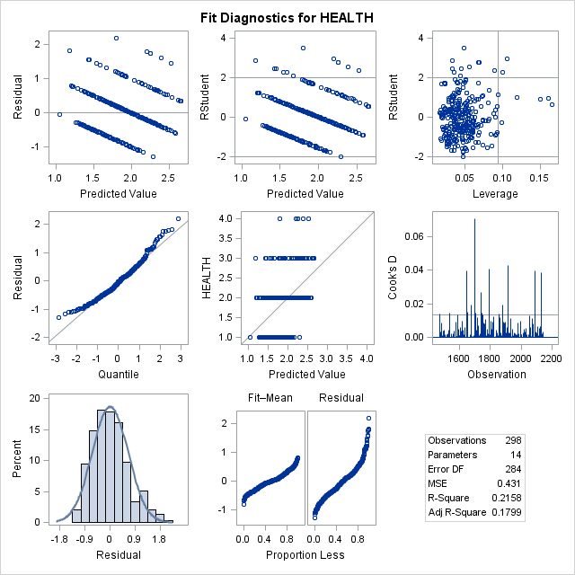

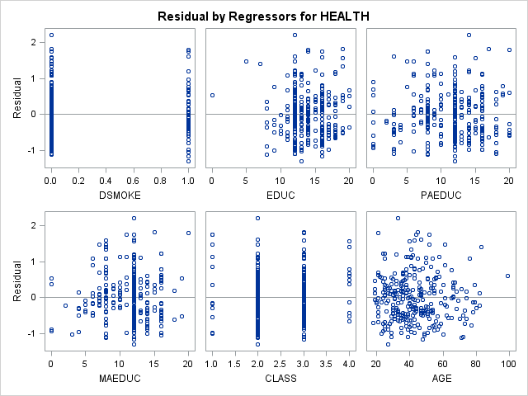

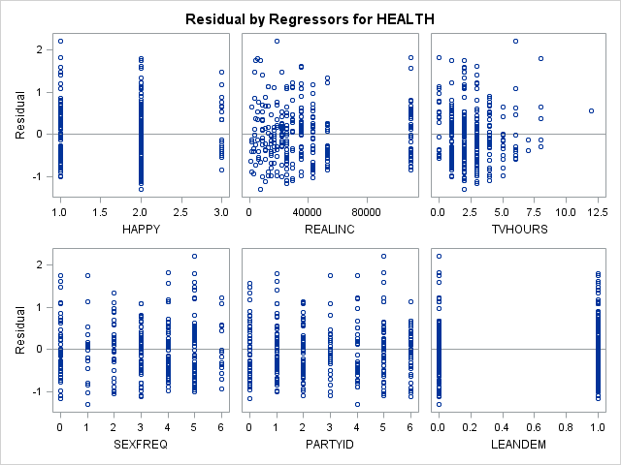

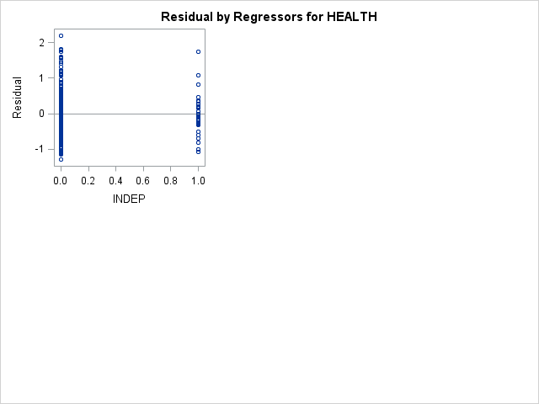

|  |
| --- |
| **V506 HOMEWORK07 - JIVITESH POOJARY AND QIWEN ZHU** |

**The REG Procedure**

**Model: MODEL1**

**Dependent Variable: HEALTH**

|  |  |
| --- | --- |
| **Number of Observations Read** | 4677 |
| **Number of Observations Used** | 328 |
| **Number of Observations with Missing Values** | 4349 |

| **Analysis of Variance** | | | | | |
| --- | --- | --- | --- | --- | --- |
| **Source** | **DF** | **Sum of Squares** | **Mean Square** | **F Value** | **Pr > F** |
| **Model** | 9 | 36.87265 | 4.09696 | 9.70 | <.0001 |
| **Error** | 318 | 134.24930 | 0.42217 |  |  |
| **Corrected Total** | 327 | 171.12195 |  |  |  |

|  |  |  |  |
| --- | --- | --- | --- |
| **Root MSE** | 0.64974 | **R-Square** | 0.2155 |
| **Dependent Mean** | 1.87805 | **Adj R-Sq** | 0.1933 |
| **Coeff Var** | 34.59677 |  |  |

| **Parameter Estimates** | | | | | | | |
| --- | --- | --- | --- | --- | --- | --- | --- |
| **Variable** | **DF** | **Parameter Estimate** | **Standard Error** | **t Value** | **Pr > |t|** | **Standardized Estimate** | **Variance Inflation** |
| **Intercept** | 1 | 1.97637 | 0.31965 | 6.18 | <.0001 | 0 | 0 |
| **DSMOKE** | 1 | 0.22024 | 0.09183 | 2.40 | 0.0170 | 0.12745 | 1.14473 |
| **EDUC** | 1 | -0.02052 | 0.01588 | -1.29 | 0.1972 | -0.07929 | 1.52621 |
| **PAEDUC** | 1 | -0.01201 | 0.00963 | -1.25 | 0.2130 | -0.07275 | 1.37780 |
| **AGE** | 1 | -0.00127 | 0.00270 | -0.47 | 0.6378 | -0.02675 | 1.30677 |
| **HAPPY** | 1 | 0.24954 | 0.06516 | 3.83 | 0.0002 | 0.20051 | 1.11131 |
| **REALINC** | 1 | -0.00000136 | 0.00000128 | -1.06 | 0.2878 | -0.06149 | 1.35208 |
| **TVHOURS** | 1 | 0.04846 | 0.02192 | 2.21 | 0.0278 | 0.11654 | 1.12666 |
| **SEXFREQ** | 1 | -0.06857 | 0.02264 | -3.03 | 0.0027 | -0.17128 | 1.29684 |
| **INDEP** | 1 | 0.18136 | 0.11576 | 1.57 | 0.1182 | 0.08036 | 1.06650 |

|  |
| --- |
| **V506 HOMEWORK07 - JIVITESH POOJARY AND QIWEN ZHU** |

**The REG Procedure**

**Model: MODEL1**

**Dependent Variable: HEALTH**

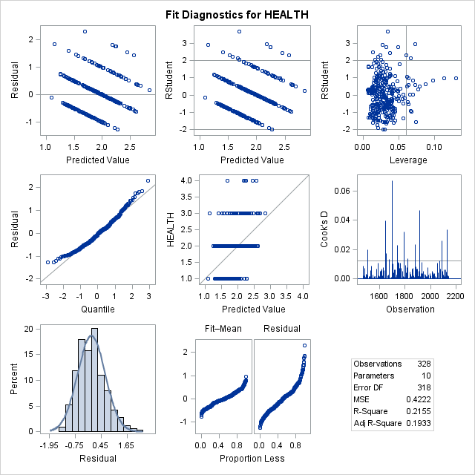

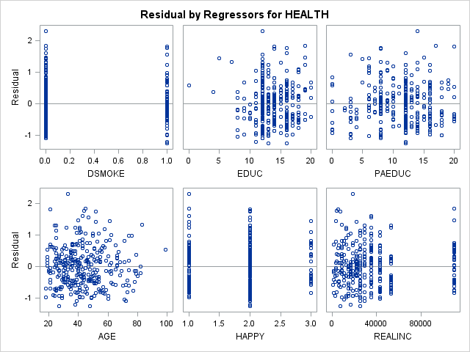

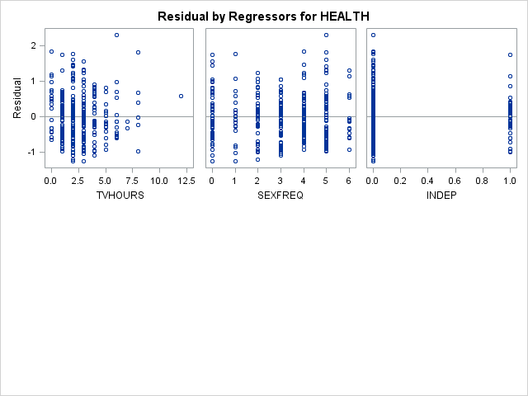

|  |
| --- |
| **V506 HOMEWORK07 - JIVITESH POOJARY AND QIWEN ZHU** |

**The REG Procedure**

**Model: MODEL1**

**Dependent Variable: HEALTH**

|  |  |
| --- | --- |
| **Number of Observations Read** | 4677 |
| **Number of Observations Used** | 328 |
| **Number of Observations with Missing Values** | 4349 |

| **Analysis of Variance** | | | | | |
| --- | --- | --- | --- | --- | --- |
| **Source** | **DF** | **Sum of Squares** | **Mean Square** | **F Value** | **Pr > F** |
| **Model** | 8 | 36.77892 | 4.59737 | 10.92 | <.0001 |
| **Error** | 319 | 134.34303 | 0.42114 |  |  |
| **Corrected Total** | 327 | 171.12195 |  |  |  |

|  |  |  |  |
| --- | --- | --- | --- |
| **Root MSE** | 0.64895 | **R-Square** | 0.2149 |
| **Dependent Mean** | 1.87805 | **Adj R-Sq** | 0.1952 |
| **Coeff Var** | 34.55456 |  |  |

| **Parameter Estimates** | | | | | | | |
| --- | --- | --- | --- | --- | --- | --- | --- |
| **Variable** | **DF** | **Parameter Estimate** | **Standard Error** | **t Value** | **Pr > |t|** | **Standardized Estimate** | **Variance Inflation** |
| **Intercept** | 1 | 1.88707 | 0.25708 | 7.34 | <.0001 | 0 | 0 |
| **DSMOKE** | 1 | 0.22274 | 0.09157 | 2.43 | 0.0155 | 0.12890 | 1.14091 |
| **EDUC** | 1 | -0.01998 | 0.01582 | -1.26 | 0.2076 | -0.07718 | 1.51805 |
| **PAEDUC** | 1 | -0.01089 | 0.00931 | -1.17 | 0.2433 | -0.06594 | 1.29303 |
| **HAPPY** | 1 | 0.25249 | 0.06478 | 3.90 | 0.0001 | 0.20289 | 1.10100 |
| **REALINC** | 1 | -0.00000143 | 0.00000127 | -1.13 | 0.2609 | -0.06456 | 1.33494 |
| **TVHOURS** | 1 | 0.04787 | 0.02186 | 2.19 | 0.0293 | 0.11512 | 1.12300 |
| **SEXFREQ** | 1 | -0.06446 | 0.02087 | -3.09 | 0.0022 | -0.16101 | 1.10455 |
| **INDEP** | 1 | 0.18257 | 0.11559 | 1.58 | 0.1152 | 0.08090 | 1.06597 |

|  |
| --- |
| **V506 HOMEWORK07 - JIVITESH POOJARY AND QIWEN ZHU** |

**The REG Procedure**

**Model: MODEL1**

**Dependent Variable: HEALTH**

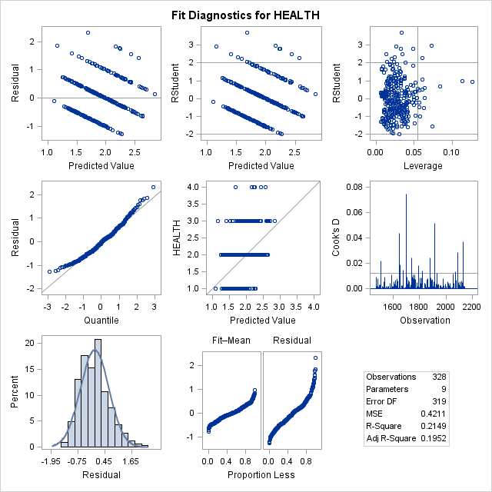

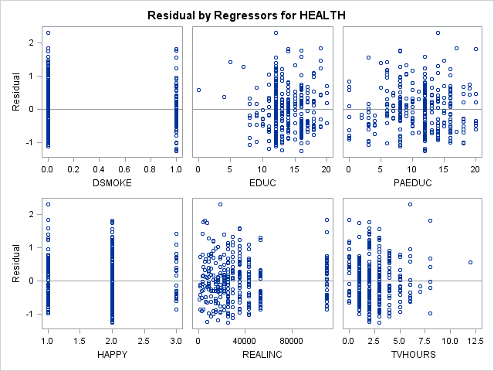

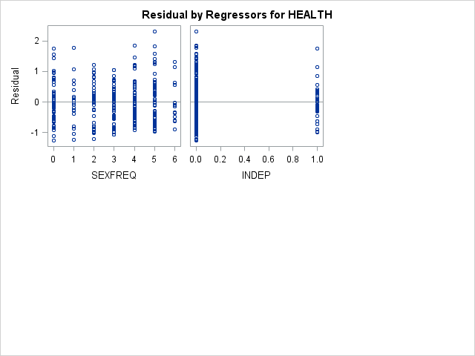

|  |
| --- |
| **V506 HOMEWORK07 - JIVITESH POOJARY AND QIWEN ZHU** |

**The REG Procedure**

**Model: MODEL1**

**Dependent Variable: HEALTH**

|  |  |
| --- | --- |
| **Number of Observations Read** | 4677 |
| **Number of Observations Used** | 328 |
| **Number of Observations with Missing Values** | 4349 |

| **Analysis of Variance** | | | | | |
| --- | --- | --- | --- | --- | --- |
| **Source** | **DF** | **Sum of Squares** | **Mean Square** | **F Value** | **Pr > F** |
| **Model** | 7 | 36.24472 | 5.17782 | 12.28 | <.0001 |
| **Error** | 320 | 134.87723 | 0.42149 |  |  |
| **Corrected Total** | 327 | 171.12195 |  |  |  |

|  |  |  |  |
| --- | --- | --- | --- |
| **Root MSE** | 0.64922 | **R-Square** | 0.2118 |
| **Dependent Mean** | 1.87805 | **Adj R-Sq** | 0.1946 |
| **Coeff Var** | 34.56905 |  |  |

| **Parameter Estimates** | | | | | | | |
| --- | --- | --- | --- | --- | --- | --- | --- |
| **Variable** | **DF** | **Parameter Estimate** | **Standard Error** | **t Value** | **Pr > |t|** | **Standardized Estimate** | **Variance Inflation** |
| **Intercept** | 1 | 1.89782 | 0.25701 | 7.38 | <.0001 | 0 | 0 |
| **DSMOKE** | 1 | 0.23298 | 0.09115 | 2.56 | 0.0111 | 0.13482 | 1.12966 |
| **EDUC** | 1 | -0.02410 | 0.01540 | -1.57 | 0.1185 | -0.09312 | 1.43663 |
| **PAEDUC** | 1 | -0.01264 | 0.00919 | -1.38 | 0.1697 | -0.07658 | 1.25677 |
| **HAPPY** | 1 | 0.25766 | 0.06465 | 3.99 | <.0001 | 0.20704 | 1.09547 |
| **TVHOURS** | 1 | 0.05073 | 0.02172 | 2.34 | 0.0201 | 0.12200 | 1.10787 |
| **SEXFREQ** | 1 | -0.06778 | 0.02067 | -3.28 | 0.0012 | -0.16931 | 1.08250 |
| **INDEP** | 1 | 0.19738 | 0.11489 | 1.72 | 0.0868 | 0.08746 | 1.05217 |

|  |
| --- |
| **V506 HOMEWORK07 - JIVITESH POOJARY AND QIWEN ZHU** |

**The REG Procedure**

**Model: MODEL1**

**Dependent Variable: HEALTH**

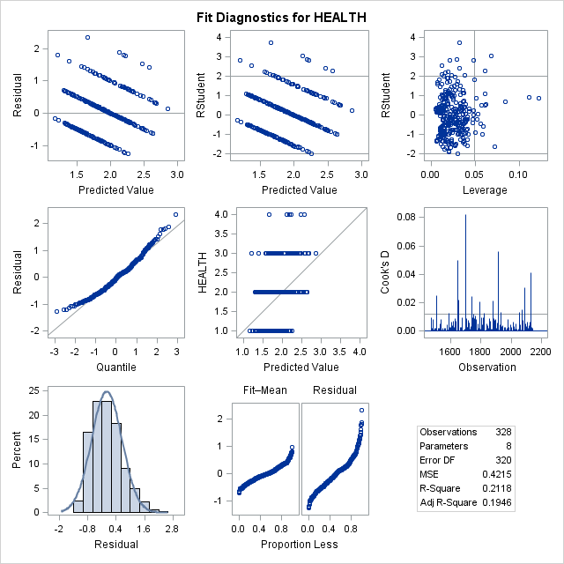

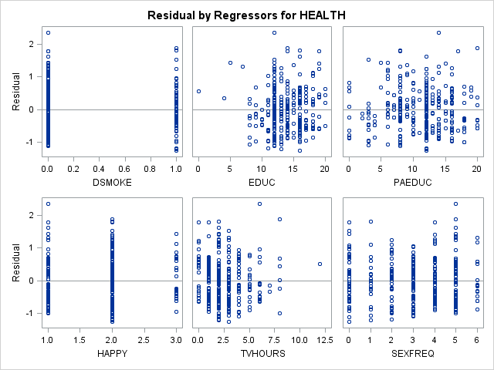

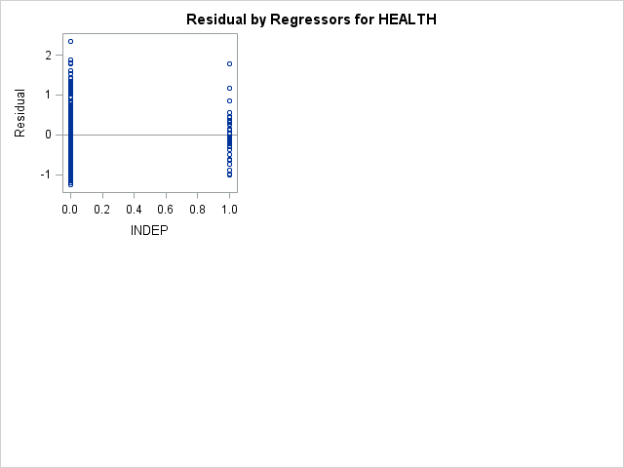

|  |
| --- |
| **V506 HOMEWORK07 - JIVITESH POOJARY AND QIWEN ZHU** |

**The REG Procedure**

**Model: MODEL1**

**Dependent Variable: HEALTH**

|  |  |
| --- | --- |
| **Number of Observations Read** | 4677 |
| **Number of Observations Used** | 328 |
| **Number of Observations with Missing Values** | 4349 |

| **Analysis of Variance** | | | | | |
| --- | --- | --- | --- | --- | --- |
| **Source** | **DF** | **Sum of Squares** | **Mean Square** | **F Value** | **Pr > F** |
| **Model** | 6 | 35.44630 | 5.90772 | 13.98 | <.0001 |
| **Error** | 321 | 135.67565 | 0.42267 |  |  |
| **Corrected Total** | 327 | 171.12195 |  |  |  |

|  |  |  |  |
| --- | --- | --- | --- |
| **Root MSE** | 0.65013 | **R-Square** | 0.2071 |
| **Dependent Mean** | 1.87805 | **Adj R-Sq** | 0.1923 |
| **Coeff Var** | 34.61717 |  |  |

| **Parameter Estimates** | | | | | | | |
| --- | --- | --- | --- | --- | --- | --- | --- |
| **Variable** | **DF** | **Parameter Estimate** | **Standard Error** | **t Value** | **Pr > |t|** | **Standardized Estimate** | **Variance Inflation** |
| **Intercept** | 1 | 1.87428 | 0.25680 | 7.30 | <.0001 | 0 | 0 |
| **DSMOKE** | 1 | 0.22906 | 0.09124 | 2.51 | 0.0125 | 0.13255 | 1.12856 |
| **EDUC** | 1 | -0.03314 | 0.01395 | -2.38 | 0.0181 | -0.12801 | 1.17565 |
| **HAPPY** | 1 | 0.26213 | 0.06465 | 4.05 | <.0001 | 0.21063 | 1.09271 |
| **TVHOURS** | 1 | 0.05117 | 0.02175 | 2.35 | 0.0192 | 0.12307 | 1.10762 |
| **SEXFREQ** | 1 | -0.06730 | 0.02070 | -3.25 | 0.0013 | -0.16811 | 1.08220 |
| **INDEP** | 1 | 0.18420 | 0.11465 | 1.61 | 0.1091 | 0.08162 | 1.04486 |

|  |
| --- |
| **V506 HOMEWORK07 - JIVITESH POOJARY AND QIWEN ZHU** |

**The REG Procedure**

**Model: MODEL1**

**Dependent Variable: HEALTH**

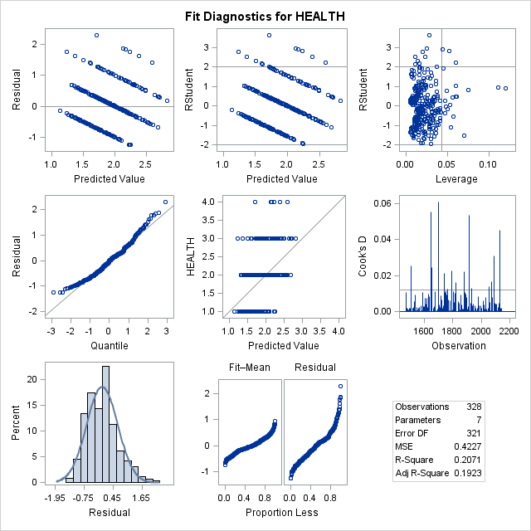

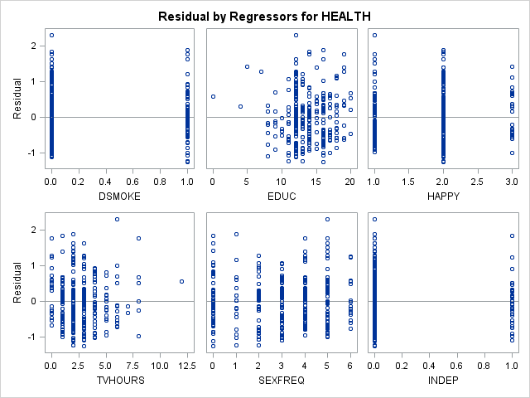

|  |
| --- |
| **V506 HOMEWORK07 - JIVITESH POOJARY AND QIWEN ZHU** |

**The REG Procedure**

**Model: MODEL1**

**Dependent Variable: HEALTH**

|  |  |
| --- | --- |
| **Number of Observations Read** | 4677 |
| **Number of Observations Used** | 328 |
| **Number of Observations with Missing Values** | 4349 |

| **Analysis of Variance** | | | | | |
| --- | --- | --- | --- | --- | --- |
| **Source** | **DF** | **Sum of Squares** | **Mean Square** | **F Value** | **Pr > F** |
| **Model** | 5 | 34.35532 | 6.87106 | 16.18 | <.0001 |
| **Error** | 322 | 136.76663 | 0.42474 |  |  |
| **Corrected Total** | 327 | 171.12195 |  |  |  |

|  |  |  |  |
| --- | --- | --- | --- |
| **Root MSE** | 0.65172 | **R-Square** | 0.2008 |
| **Dependent Mean** | 1.87805 | **Adj R-Sq** | 0.1884 |
| **Coeff Var** | 34.70206 |  |  |

| **Parameter Estimates** | | | | | | | |
| --- | --- | --- | --- | --- | --- | --- | --- |
| **Variable** | **DF** | **Parameter Estimate** | **Standard Error** | **t Value** | **Pr > |t|** | **Standardized Estimate** | **Variance Inflation** |
| **Intercept** | 1 | 1.91904 | 0.25591 | 7.50 | <.0001 | 0 | 0 |
| **DSMOKE** | 1 | 0.23999 | 0.09120 | 2.63 | 0.0089 | 0.13888 | 1.12228 |
| **EDUC** | 1 | -0.03629 | 0.01384 | -2.62 | 0.0092 | -0.14019 | 1.15238 |
| **HAPPY** | 1 | 0.26585 | 0.06477 | 4.10 | <.0001 | 0.21362 | 1.09131 |
| **TVHOURS** | 1 | 0.05175 | 0.02180 | 2.37 | 0.0182 | 0.12446 | 1.10732 |
| **SEXFREQ** | 1 | -0.06419 | 0.02066 | -3.11 | 0.0021 | -0.16033 | 1.07270 |

|  |
| --- |
| **V506 HOMEWORK07 - JIVITESH POOJARY AND QIWEN ZHU** |

**The REG Procedure**

**Model: MODEL1**

**Dependent Variable: HEALTH**

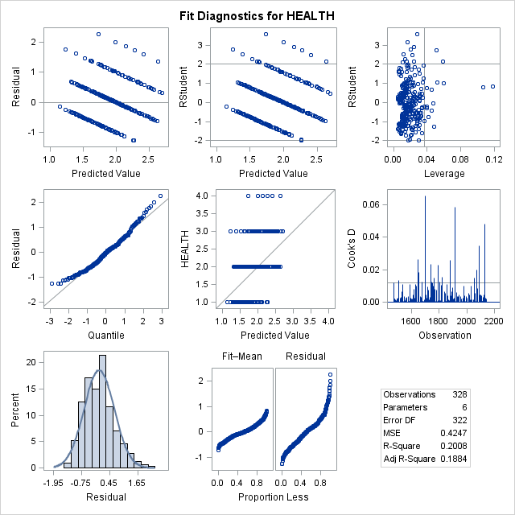

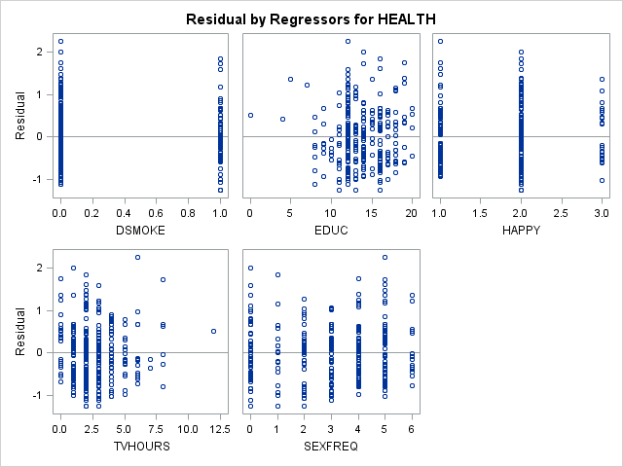

|  |
| --- |
| **V506 HOMEWORK07 - JIVITESH POOJARY AND QIWEN ZHU** |

**The CORR Procedure**

|  |  |
| --- | --- |
| **14 Variables:** | HEALTH DSMOKE EDUC PAEDUC MAEDUC CLASS AGE HAPPY REALINC TVHOURS SEXFREQ PARTYID LEANDEM INDEP |

| **Simple Statistics** | | | | | | |
| --- | --- | --- | --- | --- | --- | --- |
| **Variable** | **N** | **Mean** | **Std Dev** | **Sum** | **Minimum** | **Maximum** |
| **HEALTH** | 4677 | 1.86252 | 0.77639 | 8711 | 1.00000 | 4.00000 |
| **DSMOKE** | 1211 | 0.27168 | 0.44501 | 329.00000 | 0 | 1.00000 |
| **EDUC** | 4677 | 13.62561 | 2.77212 | 63727 | 0 | 20.00000 |
| **PAEDUC** | 4677 | 11.08852 | 4.21090 | 51861 | 0 | 20.00000 |
| **MAEDUC** | 4391 | 11.32202 | 3.41051 | 49715 | 0 | 20.00000 |
| **CLASS** | 4677 | 2.52234 | 0.63322 | 11797 | 1.00000 | 4.00000 |
| **AGE** | 4677 | 43.27796 | 15.74055 | 202411 | 18.00000 | 99.00000 |
| **HAPPY** | 4677 | 1.78234 | 0.60410 | 8336 | 1.00000 | 3.00000 |
| **REALINC** | 4677 | 34307 | 27963 | 160454394 | 363.00000 | 110160 |
| **TVHOURS** | 2794 | 2.72047 | 2.02515 | 7601 | 0 | 24.00000 |
| **SEXFREQ** | 4677 | 3.04426 | 1.90357 | 14238 | 0 | 6.00000 |
| **PARTYID** | 4662 | 3.00257 | 2.06731 | 13998 | 0 | 7.00000 |
| **LEANDEM** | 4605 | 0.56895 | 0.49528 | 2620 | 0 | 1.00000 |
| **INDEP** | 4677 | 0.11439 | 0.31832 | 535.00000 | 0 | 1.00000 |

| **Pearson Correlation Coefficients  Prob > |r| under H0: Rho=0  Number of Observations** | | | | | | | | | | | | | | |
| --- | --- | --- | --- | --- | --- | --- | --- | --- | --- | --- | --- | --- | --- | --- |
|  | **HEALTH** | **DSMOKE** | **EDUC** | **PAEDUC** | **MAEDUC** | **CLASS** | **AGE** | **HAPPY** | **REALINC** | **TVHOURS** | **SEXFREQ** | **PARTYID** | **LEANDEM** | **INDEP** |
| **HEALTH** | |  | | --- | | 1.00000 | |  | | 4677 | | |  | | --- | | 0.15536 | | <.0001 | | 1211 | | |  | | --- | | -0.25971 | | <.0001 | | 4677 | | |  | | --- | | -0.22104 | | <.0001 | | 4677 | | |  | | --- | | -0.22277 | | <.0001 | | 4391 | | |  | | --- | | -0.19624 | | <.0001 | | 4677 | | |  | | --- | | 0.19142 | | <.0001 | | 4677 | | |  | | --- | | 0.25947 | | <.0001 | | 4677 | | |  | | --- | | -0.21295 | | <.0001 | | 4677 | | |  | | --- | | 0.21179 | | <.0001 | | 2794 | | |  | | --- | | -0.16142 | | <.0001 | | 4677 | | |  | | --- | | -0.08471 | | <.0001 | | 4662 | | |  | | --- | | 0.08941 | | <.0001 | | 4605 | | |  | | --- | | 0.02125 | | 0.1463 | | 4677 | |
| **DSMOKE** | |  | | --- | | 0.15536 | | <.0001 | | 1211 | | |  | | --- | | 1.00000 | |  | | 1211 | | |  | | --- | | -0.20495 | | <.0001 | | 1211 | | |  | | --- | | -0.08767 | | 0.0023 | | 1211 | | |  | | --- | | -0.03961 | | 0.1818 | | 1138 | | |  | | --- | | -0.13658 | | <.0001 | | 1211 | | |  | | --- | | -0.05999 | | 0.0368 | | 1211 | | |  | | --- | | 0.11481 | | <.0001 | | 1211 | | |  | | --- | | -0.17079 | | <.0001 | | 1211 | | |  | | --- | | 0.16269 | | 0.0031 | | 328 | | |  | | --- | | 0.04455 | | 0.1213 | | 1211 | | |  | | --- | | -0.02712 | | 0.3464 | | 1208 | | |  | | --- | | 0.04216 | | 0.1454 | | 1194 | | |  | | --- | | 0.04845 | | 0.0919 | | 1211 | |
| **EDUC** | |  | | --- | | -0.25971 | | <.0001 | | 4677 | | |  | | --- | | -0.20495 | | <.0001 | | 1211 | | |  | | --- | | 1.00000 | |  | | 4677 | | |  | | --- | | 0.41910 | | <.0001 | | 4677 | | |  | | --- | | 0.40392 | | <.0001 | | 4391 | | |  | | --- | | 0.31684 | | <.0001 | | 4677 | | |  | | --- | | -0.15695 | | <.0001 | | 4677 | | |  | | --- | | -0.10588 | | <.0001 | | 4677 | | |  | | --- | | 0.34468 | | <.0001 | | 4677 | | |  | | --- | | -0.26983 | | <.0001 | | 2794 | | |  | | --- | | 0.06255 | | <.0001 | | 4677 | | |  | | --- | | 0.07355 | | <.0001 | | 4662 | | |  | | --- | | -0.07217 | | <.0001 | | 4605 | | |  | | --- | | -0.06827 | | <.0001 | | 4677 | |
| **PAEDUC** | |  | | --- | | -0.22104 | | <.0001 | | 4677 | | |  | | --- | | -0.08767 | | 0.0023 | | 1211 | | |  | | --- | | 0.41910 | | <.0001 | | 4677 | | |  | | --- | | 1.00000 | |  | | 4677 | | |  | | --- | | 0.65709 | | <.0001 | | 4391 | | |  | | --- | | 0.20001 | | <.0001 | | 4677 | | |  | | --- | | -0.36018 | | <.0001 | | 4677 | | |  | | --- | | -0.05598 | | 0.0001 | | 4677 | | |  | | --- | | 0.18476 | | <.0001 | | 4677 | | |  | | --- | | -0.15623 | | <.0001 | | 2794 | | |  | | --- | | 0.13198 | | <.0001 | | 4677 | | |  | | --- | | 0.13718 | | <.0001 | | 4662 | | |  | | --- | | -0.11592 | | <.0001 | | 4605 | | |  | | --- | | -0.01553 | | 0.2882 | | 4677 | |
| **MAEDUC** | |  | | --- | | -0.22277 | | <.0001 | | 4391 | | |  | | --- | | -0.03961 | | 0.1818 | | 1138 | | |  | | --- | | 0.40392 | | <.0001 | | 4391 | | |  | | --- | | 0.65709 | | <.0001 | | 4391 | | |  | | --- | | 1.00000 | |  | | 4391 | | |  | | --- | | 0.15900 | | <.0001 | | 4391 | | |  | | --- | | -0.36633 | | <.0001 | | 4391 | | |  | | --- | | -0.05669 | | 0.0002 | | 4391 | | |  | | --- | | 0.16718 | | <.0001 | | 4391 | | |  | | --- | | -0.15074 | | <.0001 | | 2610 | | |  | | --- | | 0.13352 | | <.0001 | | 4391 | | |  | | --- | | 0.11387 | | <.0001 | | 4379 | | |  | | --- | | -0.09514 | | <.0001 | | 4324 | | |  | | --- | | -0.00629 | | 0.6767 | | 4391 | |
| **CLASS** | |  | | --- | | -0.19624 | | <.0001 | | 4677 | | |  | | --- | | -0.13658 | | <.0001 | | 1211 | | |  | | --- | | 0.31684 | | <.0001 | | 4677 | | |  | | --- | | 0.20001 | | <.0001 | | 4677 | | |  | | --- | | 0.15900 | | <.0001 | | 4391 | | |  | | --- | | 1.00000 | |  | | 4677 | | |  | | --- | | 0.08550 | | <.0001 | | 4677 | | |  | | --- | | -0.18855 | | <.0001 | | 4677 | | |  | | --- | | 0.38412 | | <.0001 | | 4677 | | |  | | --- | | -0.10434 | | <.0001 | | 2794 | | |  | | --- | | -0.00836 | | 0.5676 | | 4677 | | |  | | --- | | 0.10304 | | <.0001 | | 4662 | | |  | | --- | | -0.12739 | | <.0001 | | 4605 | | |  | | --- | | -0.09067 | | <.0001 | | 4677 | |
| **AGE** | |  | | --- | | 0.19142 | | <.0001 | | 4677 | | |  | | --- | | -0.05999 | | 0.0368 | | 1211 | | |  | | --- | | -0.15695 | | <.0001 | | 4677 | | |  | | --- | | -0.36018 | | <.0001 | | 4677 | | |  | | --- | | -0.36633 | | <.0001 | | 4391 | | |  | | --- | | 0.08550 | | <.0001 | | 4677 | | |  | | --- | | 1.00000 | |  | | 4677 | | |  | | --- | | -0.02908 | | 0.0467 | | 4677 | | |  | | --- | | -0.01605 | | 0.2725 | | 4677 | | |  | | --- | | 0.08754 | | <.0001 | | 2794 | | |  | | --- | | -0.42041 | | <.0001 | | 4677 | | |  | | --- | | -0.05126 | | 0.0005 | | 4662 | | |  | | --- | | 0.01975 | | 0.1802 | | 4605 | | |  | | --- | | -0.06508 | | <.0001 | | 4677 | |
| **HAPPY** | |  | | --- | | 0.25947 | | <.0001 | | 4677 | | |  | | --- | | 0.11481 | | <.0001 | | 1211 | | |  | | --- | | -0.10588 | | <.0001 | | 4677 | | |  | | --- | | -0.05598 | | 0.0001 | | 4677 | | |  | | --- | | -0.05669 | | 0.0002 | | 4391 | | |  | | --- | | -0.18855 | | <.0001 | | 4677 | | |  | | --- | | -0.02908 | | 0.0467 | | 4677 | | |  | | --- | | 1.00000 | |  | | 4677 | | |  | | --- | | -0.17254 | | <.0001 | | 4677 | | |  | | --- | | 0.09768 | | <.0001 | | 2794 | | |  | | --- | | -0.10897 | | <.0001 | | 4677 | | |  | | --- | | -0.06539 | | <.0001 | | 4662 | | |  | | --- | | 0.08913 | | <.0001 | | 4605 | | |  | | --- | | 0.05166 | | 0.0004 | | 4677 | |
| **REALINC** | |  | | --- | | -0.21295 | | <.0001 | | 4677 | | |  | | --- | | -0.17079 | | <.0001 | | 1211 | | |  | | --- | | 0.34468 | | <.0001 | | 4677 | | |  | | --- | | 0.18476 | | <.0001 | | 4677 | | |  | | --- | | 0.16718 | | <.0001 | | 4391 | | |  | | --- | | 0.38412 | | <.0001 | | 4677 | | |  | | --- | | -0.01605 | | 0.2725 | | 4677 | | |  | | --- | | -0.17254 | | <.0001 | | 4677 | | |  | | --- | | 1.00000 | |  | | 4677 | | |  | | --- | | -0.21068 | | <.0001 | | 2794 | | |  | | --- | | 0.16243 | | <.0001 | | 4677 | | |  | | --- | | 0.10944 | | <.0001 | | 4662 | | |  | | --- | | -0.12614 | | <.0001 | | 4605 | | |  | | --- | | -0.06781 | | <.0001 | | 4677 | |
| **TVHOURS** | |  | | --- | | 0.21179 | | <.0001 | | 2794 | | |  | | --- | | 0.16269 | | 0.0031 | | 328 | | |  | | --- | | -0.26983 | | <.0001 | | 2794 | | |  | | --- | | -0.15623 | | <.0001 | | 2794 | | |  | | --- | | -0.15074 | | <.0001 | | 2610 | | |  | | --- | | -0.10434 | | <.0001 | | 2794 | | |  | | --- | | 0.08754 | | <.0001 | | 2794 | | |  | | --- | | 0.09768 | | <.0001 | | 2794 | | |  | | --- | | -0.21068 | | <.0001 | | 2794 | | |  | | --- | | 1.00000 | |  | | 2794 | | |  | | --- | | -0.07823 | | <.0001 | | 2794 | | |  | | --- | | -0.09872 | | <.0001 | | 2790 | | |  | | --- | | 0.09158 | | <.0001 | | 2756 | | |  | | --- | | 0.03437 | | 0.0693 | | 2794 | |
| **SEXFREQ** | |  | | --- | | -0.16142 | | <.0001 | | 4677 | | |  | | --- | | 0.04455 | | 0.1213 | | 1211 | | |  | | --- | | 0.06255 | | <.0001 | | 4677 | | |  | | --- | | 0.13198 | | <.0001 | | 4677 | | |  | | --- | | 0.13352 | | <.0001 | | 4391 | | |  | | --- | | -0.00836 | | 0.5676 | | 4677 | | |  | | --- | | -0.42041 | | <.0001 | | 4677 | | |  | | --- | | -0.10897 | | <.0001 | | 4677 | | |  | | --- | | 0.16243 | | <.0001 | | 4677 | | |  | | --- | | -0.07823 | | <.0001 | | 2794 | | |  | | --- | | 1.00000 | |  | | 4677 | | |  | | --- | | 0.03862 | | 0.0084 | | 4662 | | |  | | --- | | -0.02675 | | 0.0695 | | 4605 | | |  | | --- | | 0.04141 | | 0.0046 | | 4677 | |
| **PARTYID** | |  | | --- | | -0.08471 | | <.0001 | | 4662 | | |  | | --- | | -0.02712 | | 0.3464 | | 1208 | | |  | | --- | | 0.07355 | | <.0001 | | 4662 | | |  | | --- | | 0.13718 | | <.0001 | | 4662 | | |  | | --- | | 0.11387 | | <.0001 | | 4379 | | |  | | --- | | 0.10304 | | <.0001 | | 4662 | | |  | | --- | | -0.05126 | | 0.0005 | | 4662 | | |  | | --- | | -0.06539 | | <.0001 | | 4662 | | |  | | --- | | 0.10944 | | <.0001 | | 4662 | | |  | | --- | | -0.09872 | | <.0001 | | 2790 | | |  | | --- | | 0.03862 | | 0.0084 | | 4662 | | |  | | --- | | 1.00000 | |  | | 4662 | | |  | | --- | | -0.88992 | | <.0001 | | 4605 | | |  | | --- | | -0.00045 | | 0.9756 | | 4662 | |
| **LEANDEM** | |  | | --- | | 0.08941 | | <.0001 | | 4605 | | |  | | --- | | 0.04216 | | 0.1454 | | 1194 | | |  | | --- | | -0.07217 | | <.0001 | | 4605 | | |  | | --- | | -0.11592 | | <.0001 | | 4605 | | |  | | --- | | -0.09514 | | <.0001 | | 4324 | | |  | | --- | | -0.12739 | | <.0001 | | 4605 | | |  | | --- | | 0.01975 | | 0.1802 | | 4605 | | |  | | --- | | 0.08913 | | <.0001 | | 4605 | | |  | | --- | | -0.12614 | | <.0001 | | 4605 | | |  | | --- | | 0.09158 | | <.0001 | | 2756 | | |  | | --- | | -0.02675 | | 0.0695 | | 4605 | | |  | | --- | | -0.88992 | | <.0001 | | 4605 | | |  | | --- | | 1.00000 | |  | | 4605 | | |  | | --- | | 0.31558 | | <.0001 | | 4605 | |
| **INDEP** | |  | | --- | | 0.02125 | | 0.1463 | | 4677 | | |  | | --- | | 0.04845 | | 0.0919 | | 1211 | | |  | | --- | | -0.06827 | | <.0001 | | 4677 | | |  | | --- | | -0.01553 | | 0.2882 | | 4677 | | |  | | --- | | -0.00629 | | 0.6767 | | 4391 | | |  | | --- | | -0.09067 | | <.0001 | | 4677 | | |  | | --- | | -0.06508 | | <.0001 | | 4677 | | |  | | --- | | 0.05166 | | 0.0004 | | 4677 | | |  | | --- | | -0.06781 | | <.0001 | | 4677 | | |  | | --- | | 0.03437 | | 0.0693 | | 2794 | | |  | | --- | | 0.04141 | | 0.0046 | | 4677 | | |  | | --- | | -0.00045 | | 0.9756 | | 4662 | | |  | | --- | | 0.31558 | | <.0001 | | 4605 | | |  | | --- | | 1.00000 | |  | | 4677 | |

(EXTRA CREDIT) Answer :

We are looking for interaction between the variables PAEDUC and MAEDUC to check if the interaction contribute in the final model. We have chosen these features as they do not contribute in the final set of significant variables.

We are looking for interaction between the variables AGE and HAPPY to check if the interaction contribute in the final model. We have chosen these features as we felt AGE plays an important part in our health predction and as it did not contribute in the final set of significant variables. We wanted to observe its interaction with Happiness of an individual.

We performed a non linear transformation of REALINC because it was having a different range of value than the other variables and with a log transformation we were able to adjust this range so that it would not bias our equation.

TITLE "V506 HOMEWORK07 - JIVITESH POOJARY AND QIWEN ZHU";

**PROC** **UNIVARIATE** DATA=V506.Gss_2;

VAR MAEDUC TVHOURS PARTYID SMOKE;

**RUN**;

**DATA** V506.Gtemp;

SET v506.Gss_2;

IF MAEDUC = **97** THEN MAEDUC =".";

IF MAEDUC = **98** THEN MAEDUC =".";

IF MAEDUC = **99** THEN MAEDUC =".";

IF TVHOURS = **98** THEN TVHOURS =".";

IF TVHOURS = **99** THEN TVHOURS =".";

IF PARTYID = **9** THEN PARTYID =".";

IF SMOKE = **1** THEN DSMOKE = **1**;

ELSE IF SMOKE =**2** THEN DSMOKE = **0**;

ELSE DSMOKE =".";

IF PARTYID = **0** THEN LEANDEM = **1**;

IF PARTYID = **1** THEN LEANDEM = **1**;

IF PARTYID = **2** THEN LEANDEM = **1**;

IF PARTYID = **3** THEN LEANDEM = **1**;

IF PARTYID = **4** THEN LEANDEM = **0**;

IF PARTYID = **5** THEN LEANDEM = **0**;

IF PARTYID = **6** THEN LEANDEM = **0**;

IF PARTYID = **3** THEN INDEP = **1**;

ELSE INDEP = **0**;

PnMDUC = PAEDUC * MAEDUC;

AGEHAP = AGE * HAPPY;

LGREALINC = LOG(REALINC);

**RUN**;

**PROC** **UNIVARIATE** DATA=V506.GTemp;

VAR MAEDUC TVHOURS PARTYID SMOKE;

**RUN**;

**PROC** **REG**;

MODEL HEALTH = DSMOKE EDUC PAEDUC MAEDUC PnMDUC CLASS LGREALINC AGE HAPPY AGEHAP TVHOURS SEXFREQ PARTYID LEANDEM INDEP/STB VIF;

**RUN**;

**PROC** **REG**;

MODEL HEALTH = DSMOKE EDUC CLASS LGREALINC AGEHAP TVHOURS SEXFREQ INDEP/STB VIF;

**RUN**;

**PROC** **REG**;

MODEL HEALTH = DSMOKE CLASS LGREALINC AGEHAP TVHOURS SEXFREQ INDEP/STB VIF;

**RUN**;

**PROC** **REG**;

MODEL HEALTH = DSMOKE CLASS AGEHAP TVHOURS SEXFREQ INDEP/STB VIF;

**RUN**;

**PROC** **REG**;

MODEL HEALTH = DSMOKE CLASS AGEHAP TVHOURS SEXFREQ/STB VIF;

**RUN**;

**PROC** **CORR**;

VAR HEALTH DSMOKE EDUC PnMDUC CLASS LGREALINC AGEHAP TVHOURS SEXFREQ PARTYID LEANDEM INDEP;

**RUN**;

|  |
| --- |
| **V506 HOMEWORK07 - JIVITESH POOJARY AND QIWEN ZHU** |

**The UNIVARIATE Procedure**

**Variable: MAEDUC**

| **Moments** | | | |
| --- | --- | --- | --- |
| **N** | 4677 | **Sum Weights** | 4677 |
| **Mean** | 16.5967501 | **Sum Observations** | 77623 |
| **Std Deviation** | 20.9331366 | **Variance** | 438.196208 |
| **Skewness** | 3.50667337 | **Kurtosis** | 10.73916 |
| **Uncorrected SS** | 3337295 | **Corrected SS** | 2049005.47 |
| **Coeff Variation** | 126.127926 | **Std Error Mean** | 0.30609104 |

| **Basic Statistical Measures** | | | |
| --- | --- | --- | --- |
| **Location** | | **Variability** | |
| **Mean** | 16.59675 | **Std Deviation** | 20.93314 |
| **Median** | 12.00000 | **Variance** | 438.19621 |
| **Mode** | 12.00000 | **Range** | 99.00000 |
|  |  | **Interquartile Range** | 4.00000 |

| **Tests for Location: Mu0=0** | | | | |
| --- | --- | --- | --- | --- |
| **Test** | **Statistic** | | **p Value** | |
| **Student's t** | **t** | 54.22161 | **Pr > |t|** | <.0001 |
| **Sign** | **M** | 2301.5 | **Pr >= |M|** | <.0001 |
| **Signed Rank** | **S** | 5298053 | **Pr >= |S|** | <.0001 |

| **Quantiles (Definition 5)** | |
| --- | --- |
| **Level** | **Quantile** |
| **100% Max** | 99 |
| **99%** | 98 |
| **95%** | 97 |
| **90%** | 16 |
| **75% Q3** | 14 |
| **50% Median** | 12 |
| **25% Q1** | 10 |
| **10%** | 8 |
| **5%** | 6 |
| **1%** | 0 |
| **0% Min** | 0 |

| **Extreme Observations** | | | |
| --- | --- | --- | --- |
| **Lowest** | | **Highest** | |
| **Value** | **Obs** | **Value** | **Obs** |
| 0 | 4630 | 99 | 1749 |
| 0 | 4244 | 99 | 2309 |
| 0 | 4233 | 99 | 3637 |
| 0 | 4135 | 99 | 4046 |
| 0 | 3866 | 99 | 4461 |

|  |
| --- |
| **V506 HOMEWORK07 - JIVITESH POOJARY AND QIWEN ZHU** |

**The UNIVARIATE Procedure**

**Variable: TVHOURS**

| **Moments** | | | |
| --- | --- | --- | --- |
| **N** | 2807 | **Sum Weights** | 2807 |
| **Mean** | 3.16601354 | **Sum Observations** | 8887 |
| **Std Deviation** | 6.83823466 | **Variance** | 46.7614532 |
| **Skewness** | 12.777818 | **Kurtosis** | 175.633346 |
| **Uncorrected SS** | 159349 | **Corrected SS** | 131212.638 |
| **Coeff Variation** | 215.9888 | **Std Error Mean** | 0.12906925 |

| **Basic Statistical Measures** | | | |
| --- | --- | --- | --- |
| **Location** | | **Variability** | |
| **Mean** | 3.166014 | **Std Deviation** | 6.83823 |
| **Median** | 2.000000 | **Variance** | 46.76145 |
| **Mode** | 2.000000 | **Range** | 99.00000 |
|  |  | **Interquartile Range** | 3.00000 |

| **Tests for Location: Mu0=0** | | | | |
| --- | --- | --- | --- | --- |
| **Test** | **Statistic** | | **p Value** | |
| **Student's t** | **t** | 24.52957 | **Pr > |t|** | <.0001 |
| **Sign** | **M** | 1348 | **Pr >= |M|** | <.0001 |
| **Signed Rank** | **S** | 1817778 | **Pr >= |S|** | <.0001 |

| **Quantiles (Definition 5)** | |
| --- | --- |
| **Level** | **Quantile** |
| **100% Max** | 99 |
| **99%** | 12 |
| **95%** | 6 |
| **90%** | 5 |
| **75% Q3** | 4 |
| **50% Median** | 2 |
| **25% Q1** | 1 |
| **10%** | 1 |
| **5%** | 1 |
| **1%** | 0 |
| **0% Min** | 0 |

| **Extreme Observations** | | | |
| --- | --- | --- | --- |
| **Lowest** | | **Highest** | |
| **Value** | **Obs** | **Value** | **Obs** |
| 0 | 4676 | 99 | 1638 |
| 0 | 4674 | 99 | 1899 |
| 0 | 4671 | 99 | 2222 |
| 0 | 4650 | 99 | 3515 |
| 0 | 4643 | 99 | 3698 |

| **Missing Values** | | | |
| --- | --- | --- | --- |
| **Missing Value** | **Count** | **Percent Of** | |
| **All Obs** | **Missing Obs** |
| . | 1870 | 39.98 | 100.00 |

|  |
| --- |
| **V506 HOMEWORK07 - JIVITESH POOJARY AND QIWEN ZHU** |

**The UNIVARIATE Procedure**

**Variable: PARTYID**

| **Moments** | | | |
| --- | --- | --- | --- |
| **N** | 4677 | **Sum Weights** | 4677 |
| **Mean** | 3.02180885 | **Sum Observations** | 14133 |
| **Std Deviation** | 2.09166415 | **Variance** | 4.37505892 |
| **Skewness** | 0.09299129 | **Kurtosis** | -1.2242317 |
| **Uncorrected SS** | 63165 | **Corrected SS** | 20457.7755 |
| **Coeff Variation** | 69.2189431 | **Std Error Mean** | 0.03058498 |

| **Basic Statistical Measures** | | | |
| --- | --- | --- | --- |
| **Location** | | **Variability** | |
| **Mean** | 3.021809 | **Std Deviation** | 2.09166 |
| **Median** | 3.000000 | **Variance** | 4.37506 |
| **Mode** | 1.000000 | **Range** | 9.00000 |
|  |  | **Interquartile Range** | 4.00000 |

| **Tests for Location: Mu0=0** | | | | |
| --- | --- | --- | --- | --- |
| **Test** | **Statistic** | | **p Value** | |
| **Student's t** | **t** | 98.8004 | **Pr > |t|** | <.0001 |
| **Sign** | **M** | 2034 | **Pr >= |M|** | <.0001 |
| **Signed Rank** | **S** | 4138173 | **Pr >= |S|** | <.0001 |

| **Quantiles (Definition 5)** | |
| --- | --- |
| **Level** | **Quantile** |
| **100% Max** | 9 |
| **99%** | 7 |
| **95%** | 6 |
| **90%** | 6 |
| **75% Q3** | 5 |
| **50% Median** | 3 |
| **25% Q1** | 1 |
| **10%** | 0 |
| **5%** | 0 |
| **1%** | 0 |
| **0% Min** | 0 |

| **Extreme Observations** | | | |
| --- | --- | --- | --- |
| **Lowest** | | **Highest** | |
| **Value** | **Obs** | **Value** | **Obs** |
| 0 | 4659 | 9 | 2895 |
| 0 | 4656 | 9 | 2927 |
| 0 | 4651 | 9 | 2995 |
| 0 | 4646 | 9 | 3287 |
| 0 | 4636 | 9 | 3698 |

|  |
| --- |
| **V506 HOMEWORK07 - JIVITESH POOJARY AND QIWEN ZHU** |

**The UNIVARIATE Procedure**

**Variable: SMOKE**

| **Moments** | | | |
| --- | --- | --- | --- |
| **N** | 1211 | **Sum Weights** | 1211 |
| **Mean** | 1.7283237 | **Sum Observations** | 2093 |
| **Std Deviation** | 0.44500766 | **Variance** | 0.19803182 |
| **Skewness** | -1.0278538 | **Kurtosis** | -0.9450801 |
| **Uncorrected SS** | 3857 | **Corrected SS** | 239.618497 |
| **Coeff Variation** | 25.7479347 | **Std Error Mean** | 0.01278779 |

| **Basic Statistical Measures** | | | |
| --- | --- | --- | --- |
| **Location** | | **Variability** | |
| **Mean** | 1.728324 | **Std Deviation** | 0.44501 |
| **Median** | 2.000000 | **Variance** | 0.19803 |
| **Mode** | 2.000000 | **Range** | 1.00000 |
|  |  | **Interquartile Range** | 1.00000 |

| **Tests for Location: Mu0=0** | | | | |
| --- | --- | --- | --- | --- |
| **Test** | **Statistic** | | **p Value** | |
| **Student's t** | **t** | 135.1542 | **Pr > |t|** | <.0001 |
| **Sign** | **M** | 605.5 | **Pr >= |M|** | <.0001 |
| **Signed Rank** | **S** | 366933 | **Pr >= |S|** | <.0001 |

| **Quantiles (Definition 5)** | |
| --- | --- |
| **Level** | **Quantile** |
| **100% Max** | 2 |
| **99%** | 2 |
| **95%** | 2 |
| **90%** | 2 |
| **75% Q3** | 2 |
| **50% Median** | 2 |
| **25% Q1** | 1 |
| **10%** | 1 |
| **5%** | 1 |
| **1%** | 1 |
| **0% Min** | 1 |

| **Extreme Observations** | | | |
| --- | --- | --- | --- |
| **Lowest** | | **Highest** | |
| **Value** | **Obs** | **Value** | **Obs** |
| 1 | 3294 | 2 | 3212 |
| 1 | 3287 | 2 | 3213 |
| 1 | 3271 | 2 | 3227 |
| 1 | 3241 | 2 | 3251 |
| 1 | 3223 | 2 | 3281 |

| **Missing Values** | | | |
| --- | --- | --- | --- |
| **Missing Value** | **Count** | **Percent Of** | |
| **All Obs** | **Missing Obs** |
| . | 3466 | 74.11 | 100.00 |

|  |
| --- |
| **V506 HOMEWORK07 - JIVITESH POOJARY AND QIWEN ZHU** |

**The UNIVARIATE Procedure**

**Variable: MAEDUC**

| **Moments** | | | |
| --- | --- | --- | --- |
| **N** | 4391 | **Sum Weights** | 4391 |
| **Mean** | 11.3220223 | **Sum Observations** | 49715 |
| **Std Deviation** | 3.41051104 | **Variance** | 11.6315855 |
| **Skewness** | -0.7112096 | **Kurtosis** | 1.33549507 |
| **Uncorrected SS** | 613937 | **Corrected SS** | 51062.6604 |
| **Coeff Variation** | 30.1228079 | **Std Error Mean** | 0.05146805 |

| **Basic Statistical Measures** | | | |
| --- | --- | --- | --- |
| **Location** | | **Variability** | |
| **Mean** | 11.32202 | **Std Deviation** | 3.41051 |
| **Median** | 12.00000 | **Variance** | 11.63159 |
| **Mode** | 12.00000 | **Range** | 20.00000 |
|  |  | **Interquartile Range** | 4.00000 |

| **Tests for Location: Mu0=0** | | | | |
| --- | --- | --- | --- | --- |
| **Test** | **Statistic** | | **p Value** | |
| **Student's t** | **t** | 219.9816 | **Pr > |t|** | <.0001 |
| **Sign** | **M** | 2158.5 | **Pr >= |M|** | <.0001 |
| **Signed Rank** | **S** | 4660202 | **Pr >= |S|** | <.0001 |

| **Quantiles (Definition 5)** | |
| --- | --- |
| **Level** | **Quantile** |
| **100% Max** | 20 |
| **99%** | 18 |
| **95%** | 16 |
| **90%** | 16 |
| **75% Q3** | 13 |
| **50% Median** | 12 |
| **25% Q1** | 9 |
| **10%** | 7 |
| **5%** | 5 |
| **1%** | 0 |
| **0% Min** | 0 |

| **Extreme Observations** | | | |
| --- | --- | --- | --- |
| **Lowest** | | **Highest** | |
| **Value** | **Obs** | **Value** | **Obs** |
| 0 | 4630 | 20 | 4253 |
| 0 | 4244 | 20 | 4328 |
| 0 | 4233 | 20 | 4345 |
| 0 | 4135 | 20 | 4348 |
| 0 | 3866 | 20 | 4635 |

| **Missing Values** | | | |
| --- | --- | --- | --- |
| **Missing Value** | **Count** | **Percent Of** | |
| **All Obs** | **Missing Obs** |
| . | 286 | 6.12 | 100.00 |

|  |
| --- |
| **V506 HOMEWORK07 - JIVITESH POOJARY AND QIWEN ZHU** |

**The UNIVARIATE Procedure**

**Variable: TVHOURS**

| **Moments** | | | |
| --- | --- | --- | --- |
| **N** | 2794 | **Sum Weights** | 2794 |
| **Mean** | 2.72047244 | **Sum Observations** | 7601 |
| **Std Deviation** | 2.02514527 | **Variance** | 4.10121338 |
| **Skewness** | 2.4897207 | **Kurtosis** | 12.7900041 |
| **Uncorrected SS** | 32133 | **Corrected SS** | 11454.689 |
| **Coeff Variation** | 74.4409406 | **Std Error Mean** | 0.03831272 |

| **Basic Statistical Measures** | | | |
| --- | --- | --- | --- |
| **Location** | | **Variability** | |
| **Mean** | 2.720472 | **Std Deviation** | 2.02515 |
| **Median** | 2.000000 | **Variance** | 4.10121 |
| **Mode** | 2.000000 | **Range** | 24.00000 |
|  |  | **Interquartile Range** | 2.00000 |

| **Tests for Location: Mu0=0** | | | | |
| --- | --- | --- | --- | --- |
| **Test** | **Statistic** | | **p Value** | |
| **Student's t** | **t** | 71.00703 | **Pr > |t|** | <.0001 |
| **Sign** | **M** | 1341.5 | **Pr >= |M|** | <.0001 |
| **Signed Rank** | **S** | 1800293 | **Pr >= |S|** | <.0001 |

| **Quantiles (Definition 5)** | |
| --- | --- |
| **Level** | **Quantile** |
| **100% Max** | 24 |
| **99%** | 10 |
| **95%** | 6 |
| **90%** | 5 |
| **75% Q3** | 3 |
| **50% Median** | 2 |
| **25% Q1** | 1 |
| **10%** | 1 |
| **5%** | 1 |
| **1%** | 0 |
| **0% Min** | 0 |

| **Extreme Observations** | | | |
| --- | --- | --- | --- |
| **Lowest** | | **Highest** | |
| **Value** | **Obs** | **Value** | **Obs** |
| 0 | 4676 | 15 | 4175 |
| 0 | 4674 | 16 | 1522 |
| 0 | 4671 | 18 | 4199 |
| 0 | 4650 | 22 | 3352 |
| 0 | 4643 | 24 | 2101 |

| **Missing Values** | | | |
| --- | --- | --- | --- |
| **Missing Value** | **Count** | **Percent Of** | |
| **All Obs** | **Missing Obs** |
| . | 1883 | 40.26 | 100.00 |

|  |
| --- |
| **V506 HOMEWORK07 - JIVITESH POOJARY AND QIWEN ZHU** |

**The UNIVARIATE Procedure**

**Variable: PARTYID**

| **Moments** | | | |
| --- | --- | --- | --- |
| **N** | 4662 | **Sum Weights** | 4662 |
| **Mean** | 3.002574 | **Sum Observations** | 13998 |
| **Std Deviation** | 2.06730607 | **Variance** | 4.27375437 |
| **Skewness** | 0.04669673 | **Kurtosis** | -1.3570765 |
| **Uncorrected SS** | 61950 | **Corrected SS** | 19919.9691 |
| **Coeff Variation** | 68.8511279 | **Std Error Mean** | 0.0302774 |

| **Basic Statistical Measures** | | | |
| --- | --- | --- | --- |
| **Location** | | **Variability** | |
| **Mean** | 3.002574 | **Std Deviation** | 2.06731 |
| **Median** | 3.000000 | **Variance** | 4.27375 |
| **Mode** | 1.000000 | **Range** | 7.00000 |
|  |  | **Interquartile Range** | 4.00000 |

| **Tests for Location: Mu0=0** | | | | |
| --- | --- | --- | --- | --- |
| **Test** | **Statistic** | | **p Value** | |
| **Student's t** | **t** | 99.1688 | **Pr > |t|** | <.0001 |
| **Sign** | **M** | 2026.5 | **Pr >= |M|** | <.0001 |
| **Signed Rank** | **S** | 4107716 | **Pr >= |S|** | <.0001 |

| **Quantiles (Definition 5)** | |
| --- | --- |
| **Level** | **Quantile** |
| **100% Max** | 7 |
| **99%** | 7 |
| **95%** | 6 |
| **90%** | 6 |
| **75% Q3** | 5 |
| **50% Median** | 3 |
| **25% Q1** | 1 |
| **10%** | 0 |
| **5%** | 0 |
| **1%** | 0 |
| **0% Min** | 0 |

| **Extreme Observations** | | | |
| --- | --- | --- | --- |
| **Lowest** | | **Highest** | |
| **Value** | **Obs** | **Value** | **Obs** |
| 0 | 4659 | 7 | 4352 |
| 0 | 4656 | 7 | 4410 |
| 0 | 4651 | 7 | 4502 |
| 0 | 4646 | 7 | 4626 |
| 0 | 4636 | 7 | 4663 |

| **Missing Values** | | | |
| --- | --- | --- | --- |
| **Missing Value** | **Count** | **Percent Of** | |
| **All Obs** | **Missing Obs** |
| . | 15 | 0.32 | 100.00 |

|  |
| --- |
| **V506 HOMEWORK07 - JIVITESH POOJARY AND QIWEN ZHU** |

**The UNIVARIATE Procedure**

**Variable: SMOKE**

| **Moments** | | | |
| --- | --- | --- | --- |
| **N** | 1211 | **Sum Weights** | 1211 |
| **Mean** | 1.7283237 | **Sum Observations** | 2093 |
| **Std Deviation** | 0.44500766 | **Variance** | 0.19803182 |
| **Skewness** | -1.0278538 | **Kurtosis** | -0.9450801 |
| **Uncorrected SS** | 3857 | **Corrected SS** | 239.618497 |
| **Coeff Variation** | 25.7479347 | **Std Error Mean** | 0.01278779 |

| **Basic Statistical Measures** | | | |
| --- | --- | --- | --- |
| **Location** | | **Variability** | |
| **Mean** | 1.728324 | **Std Deviation** | 0.44501 |
| **Median** | 2.000000 | **Variance** | 0.19803 |
| **Mode** | 2.000000 | **Range** | 1.00000 |
|  |  | **Interquartile Range** | 1.00000 |

| **Tests for Location: Mu0=0** | | | | |
| --- | --- | --- | --- | --- |
| **Test** | **Statistic** | | **p Value** | |
| **Student's t** | **t** | 135.1542 | **Pr > |t|** | <.0001 |
| **Sign** | **M** | 605.5 | **Pr >= |M|** | <.0001 |
| **Signed Rank** | **S** | 366933 | **Pr >= |S|** | <.0001 |

| **Quantiles (Definition 5)** | |
| --- | --- |
| **Level** | **Quantile** |
| **100% Max** | 2 |
| **99%** | 2 |
| **95%** | 2 |
| **90%** | 2 |
| **75% Q3** | 2 |
| **50% Median** | 2 |
| **25% Q1** | 1 |
| **10%** | 1 |
| **5%** | 1 |
| **1%** | 1 |
| **0% Min** | 1 |

| **Extreme Observations** | | | |
| --- | --- | --- | --- |
| **Lowest** | | **Highest** | |
| **Value** | **Obs** | **Value** | **Obs** |
| 1 | 3294 | 2 | 3212 |
| 1 | 3287 | 2 | 3213 |
| 1 | 3271 | 2 | 3227 |
| 1 | 3241 | 2 | 3251 |
| 1 | 3223 | 2 | 3281 |

| **Missing Values** | | | |
| --- | --- | --- | --- |
| **Missing Value** | **Count** | **Percent Of** | |
| **All Obs** | **Missing Obs** |
| . | 3466 | 74.11 | 100.00 |

|  |
| --- |
| **V506 HOMEWORK07 - JIVITESH POOJARY AND QIWEN ZHU** |

**The REG Procedure**

**Model: MODEL1**

**Dependent Variable: HEALTH**

|  |  |
| --- | --- |
| **Number of Observations Read** | 4677 |
| **Number of Observations Used** | 298 |
| **Number of Observations with Missing Values** | 4379 |

| **Analysis of Variance** | | | | | |
| --- | --- | --- | --- | --- | --- |
| **Source** | **DF** | **Sum of Squares** | **Mean Square** | **F Value** | **Pr > F** |
| **Model** | 15 | 33.96049 | 2.26403 | 5.23 | <.0001 |
| **Error** | 282 | 122.12005 | 0.43305 |  |  |
| **Corrected Total** | 297 | 156.08054 |  |  |  |

|  |  |  |  |
| --- | --- | --- | --- |
| **Root MSE** | 0.65807 | **R-Square** | 0.2176 |
| **Dependent Mean** | 1.85906 | **Adj R-Sq** | 0.1760 |
| **Coeff Var** | 35.39773 |  |  |

| **Parameter Estimates** | | | | | | | |
| --- | --- | --- | --- | --- | --- | --- | --- |
| **Variable** | **DF** | **Parameter Estimate** | **Standard Error** | **t Value** | **Pr > |t|** | **Standardized Estimate** | **Variance Inflation** |
| **Intercept** | 1 | 2.07616 | 0.69967 | 2.97 | 0.0033 | 0 | 0 |
| **DSMOKE** | 1 | 0.20091 | 0.10164 | 1.98 | 0.0491 | 0.11132 | 1.14316 |
| **EDUC** | 1 | -0.02564 | 0.01771 | -1.45 | 0.1487 | -0.09718 | 1.62343 |
| **PAEDUC** | 1 | 0.00305 | 0.02763 | 0.11 | 0.9120 | 0.01862 | 10.22411 |
| **MAEDUC** | 1 | 0.01506 | 0.02562 | 0.59 | 0.5571 | 0.06768 | 4.77685 |
| **PnMDUC** | 1 | -0.00130 | 0.00219 | -0.60 | 0.5517 | -0.13351 | 18.09340 |
| **CLASS** | 1 | -0.02519 | 0.07318 | -0.34 | 0.7310 | -0.02209 | 1.48515 |
| **LGREALINC** | 1 | -0.03903 | 0.04825 | -0.81 | 0.4193 | -0.05257 | 1.52254 |
| **AGE** | 1 | 0.00203 | 0.00792 | 0.26 | 0.7978 | 0.04275 | 10.01355 |
| **HAPPY** | 1 | 0.36560 | 0.21114 | 1.73 | 0.0844 | 0.29645 | 10.56399 |
| **AGEHAP** | 1 | -0.00241 | 0.00432 | -0.56 | 0.5763 | -0.12731 | 18.66277 |
| **TVHOURS** | 1 | 0.05405 | 0.02398 | 2.25 | 0.0250 | 0.12776 | 1.15854 |
| **SEXFREQ** | 1 | -0.05724 | 0.02436 | -2.35 | 0.0195 | -0.14339 | 1.34175 |
| **PARTYID** | 1 | 0.01038 | 0.05315 | 0.20 | 0.8454 | 0.02925 | 8.09099 |
| **LEANDEM** | 1 | -0.04346 | 0.22890 | -0.19 | 0.8495 | -0.02937 | 8.62378 |
| **INDEP** | 1 | 0.23000 | 0.16991 | 1.35 | 0.1769 | 0.09702 | 1.85164 |

|  |
| --- |
| **V506 HOMEWORK07 - JIVITESH POOJARY AND QIWEN ZHU** |

**The REG Procedure**

**Model: MODEL1**

**Dependent Variable: HEALTH**

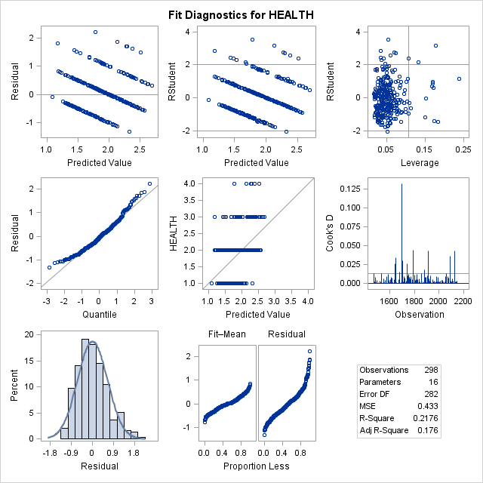

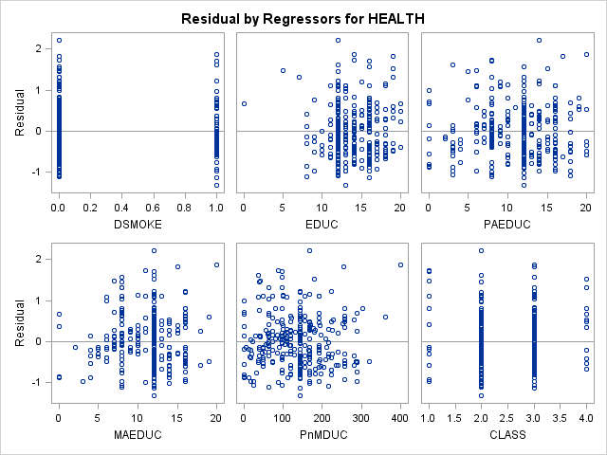

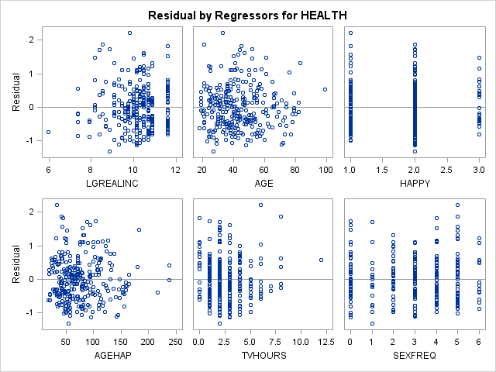

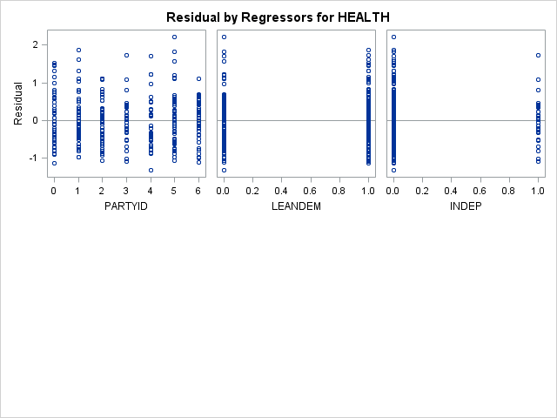

|  |
| --- |
| **V506 HOMEWORK07 - JIVITESH POOJARY AND QIWEN ZHU** |

**The REG Procedure**

**Model: MODEL1**

**Dependent Variable: HEALTH**

|  |  |
| --- | --- |
| **Number of Observations Read** | 4677 |
| **Number of Observations Used** | 328 |
| **Number of Observations with Missing Values** | 4349 |

| **Analysis of Variance** | | | | | |
| --- | --- | --- | --- | --- | --- |
| **Source** | **DF** | **Sum of Squares** | **Mean Square** | **F Value** | **Pr > F** |
| **Model** | 8 | 33.60460 | 4.20057 | 9.74 | <.0001 |
| **Error** | 319 | 137.51736 | 0.43109 |  |  |
| **Corrected Total** | 327 | 171.12195 |  |  |  |

|  |  |  |  |
| --- | --- | --- | --- |
| **Root MSE** | 0.65657 | **R-Square** | 0.1964 |
| **Dependent Mean** | 1.87805 | **Adj R-Sq** | 0.1762 |
| **Coeff Var** | 34.96041 |  |  |

| **Parameter Estimates** | | | | | | | |
| --- | --- | --- | --- | --- | --- | --- | --- |
| **Variable** | **DF** | **Parameter Estimate** | **Standard Error** | **t Value** | **Pr > |t|** | **Standardized Estimate** | **Variance Inflation** |
| **Intercept** | 1 | 2.68685 | 0.45522 | 5.90 | <.0001 | 0 | 0 |
| **DSMOKE** | 1 | 0.24949 | 0.09186 | 2.72 | 0.0070 | 0.14437 | 1.12161 |
| **EDUC** | 1 | -0.01896 | 0.01509 | -1.26 | 0.2099 | -0.07325 | 1.34951 |
| **CLASS** | 1 | -0.11334 | 0.06369 | -1.78 | 0.0761 | -0.10174 | 1.29771 |
| **LGREALINC** | 1 | -0.04559 | 0.04430 | -1.03 | 0.3042 | -0.06141 | 1.41389 |
| **AGEHAP** | 1 | 0.00244 | 0.00106 | 2.30 | 0.0222 | 0.12839 | 1.23823 |
| **TVHOURS** | 1 | 0.04824 | 0.02240 | 2.15 | 0.0320 | 0.11601 | 1.15211 |
| **SEXFREQ** | 1 | -0.05963 | 0.02256 | -2.64 | 0.0086 | -0.14894 | 1.26028 |
| **INDEP** | 1 | 0.15472 | 0.11767 | 1.31 | 0.1895 | 0.06856 | 1.07905 |

|  |
| --- |
| **V506 HOMEWORK07 - JIVITESH POOJARY AND QIWEN ZHU** |

**The REG Procedure**

**Model: MODEL1**

**Dependent Variable: HEALTH**

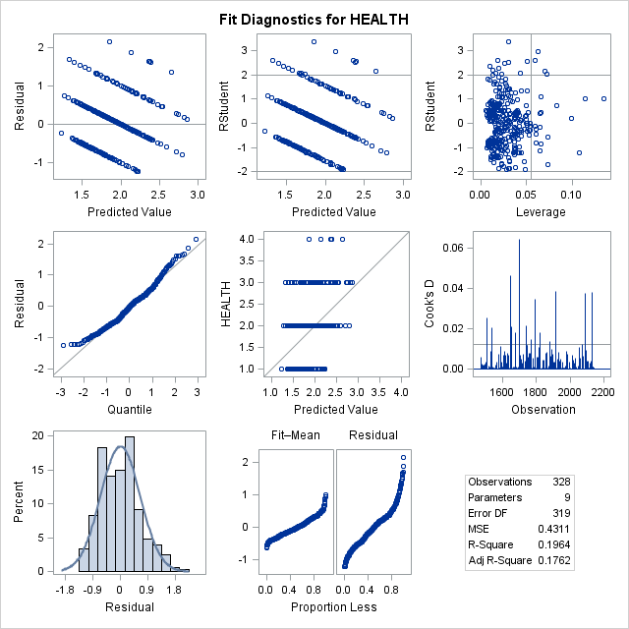

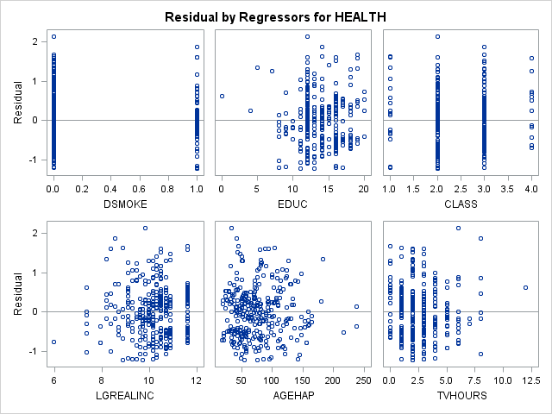

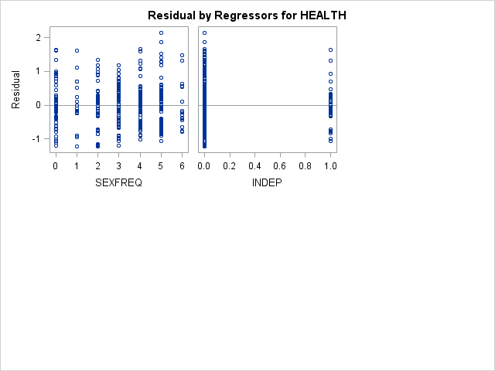

|  |
| --- |
| **V506 HOMEWORK07 - JIVITESH POOJARY AND QIWEN ZHU** |

**The REG Procedure**

**Model: MODEL1**

**Dependent Variable: HEALTH**

|  |  |
| --- | --- |
| **Number of Observations Read** | 4677 |
| **Number of Observations Used** | 328 |
| **Number of Observations with Missing Values** | 4349 |

| **Analysis of Variance** | | | | | |
| --- | --- | --- | --- | --- | --- |
| **Source** | **DF** | **Sum of Squares** | **Mean Square** | **F Value** | **Pr > F** |
| **Model** | 7 | 32.92424 | 4.70346 | 10.89 | <.0001 |
| **Error** | 320 | 138.19771 | 0.43187 |  |  |
| **Corrected Total** | 327 | 171.12195 |  |  |  |

|  |  |  |  |
| --- | --- | --- | --- |
| **Root MSE** | 0.65717 | **R-Square** | 0.1924 |
| **Dependent Mean** | 1.87805 | **Adj R-Sq** | 0.1747 |
| **Coeff Var** | 34.99198 |  |  |

| **Parameter Estimates** | | | | | | | |
| --- | --- | --- | --- | --- | --- | --- | --- |
| **Variable** | **DF** | **Parameter Estimate** | **Standard Error** | **t Value** | **Pr > |t|** | **Standardized Estimate** | **Variance Inflation** |
| **Intercept** | 1 | 2.56607 | 0.44536 | 5.76 | <.0001 | 0 | 0 |
| **DSMOKE** | 1 | 0.26361 | 0.09125 | 2.89 | 0.0041 | 0.15255 | 1.10479 |
| **CLASS** | 1 | -0.12825 | 0.06264 | -2.05 | 0.0414 | -0.11513 | 1.25265 |
| **LGREALINC** | 1 | -0.05798 | 0.04323 | -1.34 | 0.1808 | -0.07811 | 1.34378 |
| **AGEHAP** | 1 | 0.00257 | 0.00106 | 2.43 | 0.0157 | 0.13514 | 1.22679 |
| **TVHOURS** | 1 | 0.05320 | 0.02207 | 2.41 | 0.0165 | 0.12794 | 1.11632 |
| **SEXFREQ** | 1 | -0.06057 | 0.02257 | -2.68 | 0.0077 | -0.15129 | 1.25888 |
| **INDEP** | 1 | 0.16685 | 0.11737 | 1.42 | 0.1561 | 0.07393 | 1.07178 |

|  |
| --- |
| **V506 HOMEWORK07 - JIVITESH POOJARY AND QIWEN ZHU** |

**The REG Procedure**

**Model: MODEL1**

**Dependent Variable: HEALTH**

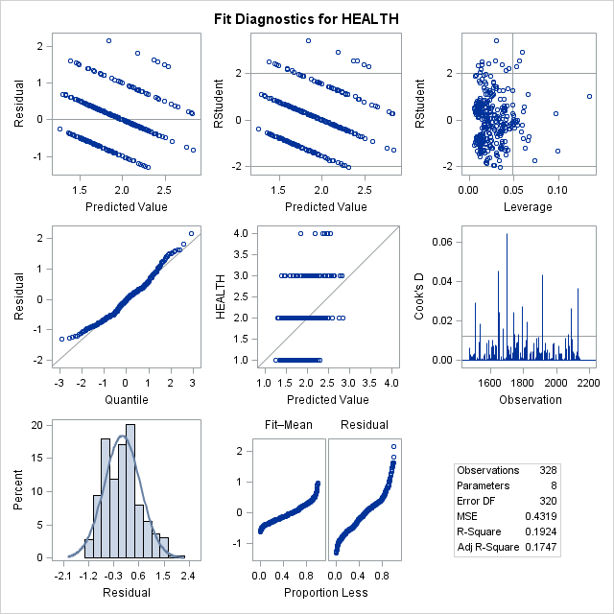

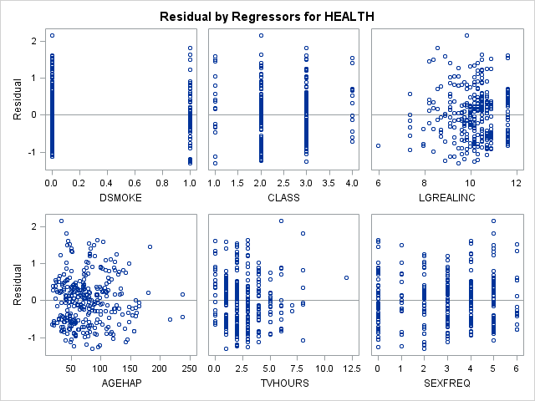

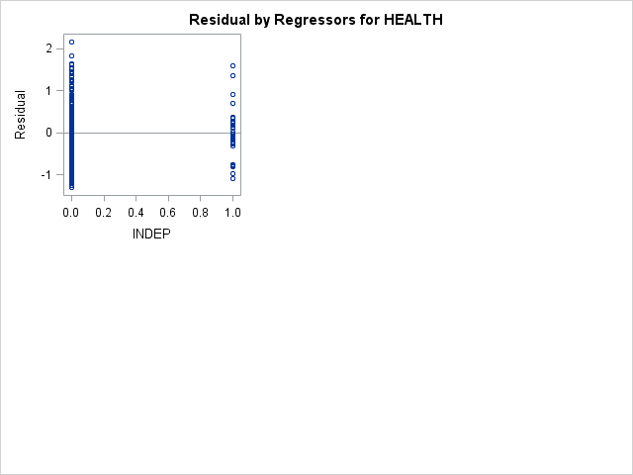

|  |
| --- |
| **V506 HOMEWORK07 - JIVITESH POOJARY AND QIWEN ZHU** |

**The REG Procedure**

**Model: MODEL1**

**Dependent Variable: HEALTH**

|  |  |
| --- | --- |
| **Number of Observations Read** | 4677 |
| **Number of Observations Used** | 328 |
| **Number of Observations with Missing Values** | 4349 |

| **Analysis of Variance** | | | | | |
| --- | --- | --- | --- | --- | --- |
| **Source** | **DF** | **Sum of Squares** | **Mean Square** | **F Value** | **Pr > F** |
| **Model** | 6 | 32.14728 | 5.35788 | 12.38 | <.0001 |
| **Error** | 321 | 138.97467 | 0.43294 |  |  |
| **Corrected Total** | 327 | 171.12195 |  |  |  |

|  |  |  |  |
| --- | --- | --- | --- |
| **Root MSE** | 0.65798 | **R-Square** | 0.1879 |
| **Dependent Mean** | 1.87805 | **Adj R-Sq** | 0.1727 |
| **Coeff Var** | 35.03551 |  |  |

| **Parameter Estimates** | | | | | | | |
| --- | --- | --- | --- | --- | --- | --- | --- |
| **Variable** | **DF** | **Parameter Estimate** | **Standard Error** | **t Value** | **Pr > |t|** | **Standardized Estimate** | **Variance Inflation** |
| **Intercept** | 1 | 2.04343 | 0.21593 | 9.46 | <.0001 | 0 | 0 |
| **DSMOKE** | 1 | 0.28064 | 0.09047 | 3.10 | 0.0021 | 0.16240 | 1.08343 |
| **CLASS** | 1 | -0.15651 | 0.05906 | -2.65 | 0.0084 | -0.14049 | 1.11095 |
| **AGEHAP** | 1 | 0.00257 | 0.00106 | 2.42 | 0.0160 | 0.13494 | 1.22678 |
| **TVHOURS** | 1 | 0.06015 | 0.02148 | 2.80 | 0.0054 | 0.14465 | 1.05480 |
| **SEXFREQ** | 1 | -0.06645 | 0.02216 | -3.00 | 0.0029 | -0.16599 | 1.21129 |
| **INDEP** | 1 | 0.17100 | 0.11748 | 1.46 | 0.1465 | 0.07577 | 1.07104 |

|  |
| --- |
| **V506 HOMEWORK07 - JIVITESH POOJARY AND QIWEN ZHU** |

**The REG Procedure**

**Model: MODEL1**

**Dependent Variable: HEALTH**

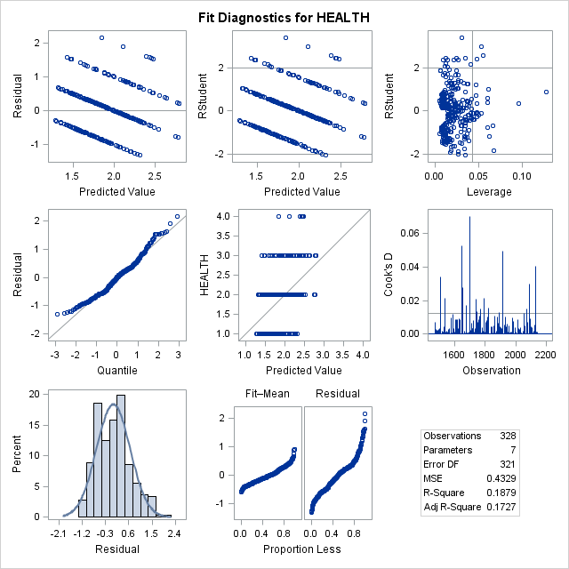

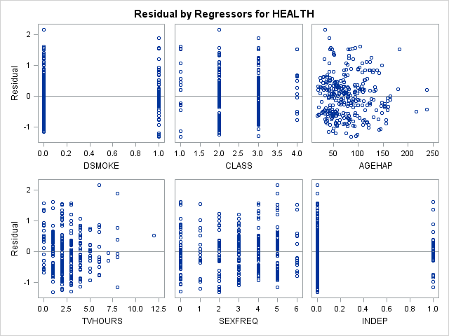

|  |
| --- |
| **V506 HOMEWORK07 - JIVITESH POOJARY AND QIWEN ZHU** |

**The REG Procedure**

**Model: MODEL1**

**Dependent Variable: HEALTH**

|  |  |
| --- | --- |
| **Number of Observations Read** | 4677 |
| **Number of Observations Used** | 328 |
| **Number of Observations with Missing Values** | 4349 |

| **Analysis of Variance** | | | | | |
| --- | --- | --- | --- | --- | --- |
| **Source** | **DF** | **Sum of Squares** | **Mean Square** | **F Value** | **Pr > F** |
| **Model** | 5 | 31.23004 | 6.24601 | 14.38 | <.0001 |
| **Error** | 322 | 139.89191 | 0.43445 |  |  |
| **Corrected Total** | 327 | 171.12195 |  |  |  |

|  |  |  |  |
| --- | --- | --- | --- |
| **Root MSE** | 0.65913 | **R-Square** | 0.1825 |
| **Dependent Mean** | 1.87805 | **Adj R-Sq** | 0.1698 |
| **Coeff Var** | 35.09631 |  |  |

| **Parameter Estimates** | | | | | | | |
| --- | --- | --- | --- | --- | --- | --- | --- |
| **Variable** | **DF** | **Parameter Estimate** | **Standard Error** | **t Value** | **Pr > |t|** | **Standardized Estimate** | **Variance Inflation** |
| **Intercept** | 1 | 2.09793 | 0.21303 | 9.85 | <.0001 | 0 | 0 |
| **DSMOKE** | 1 | 0.29030 | 0.09039 | 3.21 | 0.0015 | 0.16799 | 1.07759 |
| **CLASS** | 1 | -0.17478 | 0.05781 | -3.02 | 0.0027 | -0.15689 | 1.06078 |
| **AGEHAP** | 1 | 0.00255 | 0.00106 | 2.40 | 0.0169 | 0.13405 | 1.22663 |
| **TVHOURS** | 1 | 0.06165 | 0.02149 | 2.87 | 0.0044 | 0.14825 | 1.05238 |
| **SEXFREQ** | 1 | -0.06427 | 0.02215 | -2.90 | 0.0040 | -0.16053 | 1.20572 |

|  |
| --- |
| **V506 HOMEWORK07 - JIVITESH POOJARY AND QIWEN ZHU** |

**The REG Procedure**

**Model: MODEL1**

**Dependent Variable: HEALTH**

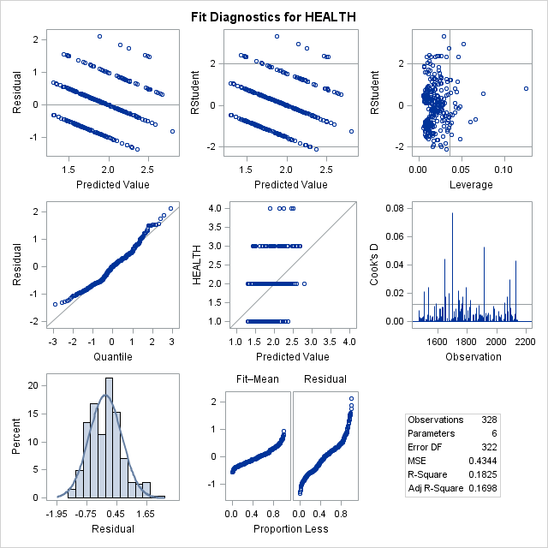

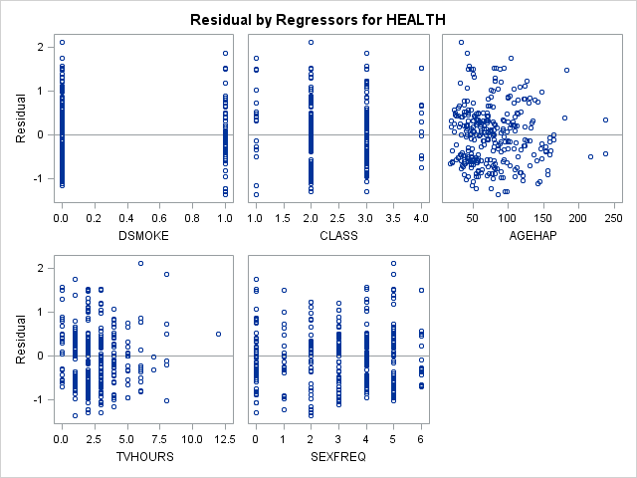

|  |
| --- |
| **V506 HOMEWORK07 - JIVITESH POOJARY AND QIWEN ZHU** |

**The CORR Procedure**

|  |  |
| --- | --- |
| **12 Variables:** | HEALTH DSMOKE EDUC PnMDUC CLASS LGREALINC AGEHAP TVHOURS SEXFREQ PARTYID LEANDEM INDEP |

| **Simple Statistics** | | | | | | |
| --- | --- | --- | --- | --- | --- | --- |
| **Variable** | **N** | **Mean** | **Std Dev** | **Sum** | **Minimum** | **Maximum** |
| **HEALTH** | 4677 | 1.86252 | 0.77639 | 8711 | 1.00000 | 4.00000 |
| **DSMOKE** | 1211 | 0.27168 | 0.44501 | 329.00000 | 0 | 1.00000 |
| **EDUC** | 4677 | 13.62561 | 2.77212 | 63727 | 0 | 20.00000 |
| **PnMDUC** | 4391 | 135.97586 | 74.15046 | 597070 | 0 | 400.00000 |
| **CLASS** | 4677 | 2.52234 | 0.63322 | 11797 | 1.00000 | 4.00000 |
| **LGREALINC** | 4677 | 10.08893 | 0.93378 | 47186 | 5.89440 | 11.60969 |
| **AGEHAP** | 4677 | 76.85953 | 39.30782 | 359472 | 18.00000 | 297.00000 |
| **TVHOURS** | 2794 | 2.72047 | 2.02515 | 7601 | 0 | 24.00000 |
| **SEXFREQ** | 4677 | 3.04426 | 1.90357 | 14238 | 0 | 6.00000 |
| **PARTYID** | 4662 | 3.00257 | 2.06731 | 13998 | 0 | 7.00000 |
| **LEANDEM** | 4605 | 0.56895 | 0.49528 | 2620 | 0 | 1.00000 |
| **INDEP** | 4677 | 0.11439 | 0.31832 | 535.00000 | 0 | 1.00000 |

| **Pearson Correlation Coefficients  Prob > |r| under H0: Rho=0  Number of Observations** | | | | | | | | | | | | |
| --- | --- | --- | --- | --- | --- | --- | --- | --- | --- | --- | --- | --- |
|  | **HEALTH** | **DSMOKE** | **EDUC** | **PnMDUC** | **CLASS** | **LGREALINC** | **AGEHAP** | **TVHOURS** | **SEXFREQ** | **PARTYID** | **LEANDEM** | **INDEP** |
| **HEALTH** | |  | | --- | | 1.00000 | |  | | 4677 | | |  | | --- | | 0.15536 | | <.0001 | | 1211 | | |  | | --- | | -0.25971 | | <.0001 | | 4677 | | |  | | --- | | -0.22926 | | <.0001 | | 4391 | | |  | | --- | | -0.19624 | | <.0001 | | 4677 | | |  | | --- | | -0.25075 | | <.0001 | | 4677 | | |  | | --- | | 0.31994 | | <.0001 | | 4677 | | |  | | --- | | 0.21179 | | <.0001 | | 2794 | | |  | | --- | | -0.16142 | | <.0001 | | 4677 | | |  | | --- | | -0.08471 | | <.0001 | | 4662 | | |  | | --- | | 0.08941 | | <.0001 | | 4605 | | |  | | --- | | 0.02125 | | 0.1463 | | 4677 | |
| **DSMOKE** | |  | | --- | | 0.15536 | | <.0001 | | 1211 | | |  | | --- | | 1.00000 | |  | | 1211 | | |  | | --- | | -0.20495 | | <.0001 | | 1211 | | |  | | --- | | -0.07816 | | 0.0083 | | 1138 | | |  | | --- | | -0.13658 | | <.0001 | | 1211 | | |  | | --- | | -0.17923 | | <.0001 | | 1211 | | |  | | --- | | 0.01881 | | 0.5131 | | 1211 | | |  | | --- | | 0.16269 | | 0.0031 | | 328 | | |  | | --- | | 0.04455 | | 0.1213 | | 1211 | | |  | | --- | | -0.02712 | | 0.3464 | | 1208 | | |  | | --- | | 0.04216 | | 0.1454 | | 1194 | | |  | | --- | | 0.04845 | | 0.0919 | | 1211 | |
| **EDUC** | |  | | --- | | -0.25971 | | <.0001 | | 4677 | | |  | | --- | | -0.20495 | | <.0001 | | 1211 | | |  | | --- | | 1.00000 | |  | | 4677 | | |  | | --- | | 0.44470 | | <.0001 | | 4391 | | |  | | --- | | 0.31684 | | <.0001 | | 4677 | | |  | | --- | | 0.34677 | | <.0001 | | 4677 | | |  | | --- | | -0.18610 | | <.0001 | | 4677 | | |  | | --- | | -0.26983 | | <.0001 | | 2794 | | |  | | --- | | 0.06255 | | <.0001 | | 4677 | | |  | | --- | | 0.07355 | | <.0001 | | 4662 | | |  | | --- | | -0.07217 | | <.0001 | | 4605 | | |  | | --- | | -0.06827 | | <.0001 | | 4677 | |
| **PnMDUC** | |  | | --- | | -0.22926 | | <.0001 | | 4391 | | |  | | --- | | -0.07816 | | 0.0083 | | 1138 | | |  | | --- | | 0.44470 | | <.0001 | | 4391 | | |  | | --- | | 1.00000 | |  | | 4391 | | |  | | --- | | 0.20949 | | <.0001 | | 4391 | | |  | | --- | | 0.15900 | | <.0001 | | 4391 | | |  | | --- | | -0.30534 | | <.0001 | | 4391 | | |  | | --- | | -0.16144 | | <.0001 | | 2610 | | |  | | --- | | 0.12575 | | <.0001 | | 4391 | | |  | | --- | | 0.12237 | | <.0001 | | 4379 | | |  | | --- | | -0.10345 | | <.0001 | | 4324 | | |  | | --- | | -0.01807 | | 0.2313 | | 4391 | |
| **CLASS** | |  | | --- | | -0.19624 | | <.0001 | | 4677 | | |  | | --- | | -0.13658 | | <.0001 | | 1211 | | |  | | --- | | 0.31684 | | <.0001 | | 4677 | | |  | | --- | | 0.20949 | | <.0001 | | 4391 | | |  | | --- | | 1.00000 | |  | | 4677 | | |  | | --- | | 0.33790 | | <.0001 | | 4677 | | |  | | --- | | -0.06487 | | <.0001 | | 4677 | | |  | | --- | | -0.10434 | | <.0001 | | 2794 | | |  | | --- | | -0.00836 | | 0.5676 | | 4677 | | |  | | --- | | 0.10304 | | <.0001 | | 4662 | | |  | | --- | | -0.12739 | | <.0001 | | 4605 | | |  | | --- | | -0.09067 | | <.0001 | | 4677 | |
| **LGREALINC** | |  | | --- | | -0.25075 | | <.0001 | | 4677 | | |  | | --- | | -0.17923 | | <.0001 | | 1211 | | |  | | --- | | 0.34677 | | <.0001 | | 4677 | | |  | | --- | | 0.15900 | | <.0001 | | 4391 | | |  | | --- | | 0.33790 | | <.0001 | | 4677 | | |  | | --- | | 1.00000 | |  | | 4677 | | |  | | --- | | -0.14952 | | <.0001 | | 4677 | | |  | | --- | | -0.23862 | | <.0001 | | 2794 | | |  | | --- | | 0.18055 | | <.0001 | | 4677 | | |  | | --- | | 0.10752 | | <.0001 | | 4662 | | |  | | --- | | -0.12289 | | <.0001 | | 4605 | | |  | | --- | | -0.06115 | | <.0001 | | 4677 | |
| **AGEHAP** | |  | | --- | | 0.31994 | | <.0001 | | 4677 | | |  | | --- | | 0.01881 | | 0.5131 | | 1211 | | |  | | --- | | -0.18610 | | <.0001 | | 4677 | | |  | | --- | | -0.30534 | | <.0001 | | 4391 | | |  | | --- | | -0.06487 | | <.0001 | | 4677 | | |  | | --- | | -0.14952 | | <.0001 | | 4677 | | |  | | --- | | 1.00000 | |  | | 4677 | | |  | | --- | | 0.12476 | | <.0001 | | 2794 | | |  | | --- | | -0.38057 | | <.0001 | | 4677 | | |  | | --- | | -0.08282 | | <.0001 | | 4662 | | |  | | --- | | 0.07672 | | <.0001 | | 4605 | | |  | | --- | | -0.01242 | | 0.3957 | | 4677 | |
| **TVHOURS** | |  | | --- | | 0.21179 | | <.0001 | | 2794 | | |  | | --- | | 0.16269 | | 0.0031 | | 328 | | |  | | --- | | -0.26983 | | <.0001 | | 2794 | | |  | | --- | | -0.16144 | | <.0001 | | 2610 | | |  | | --- | | -0.10434 | | <.0001 | | 2794 | | |  | | --- | | -0.23862 | | <.0001 | | 2794 | | |  | | --- | | 0.12476 | | <.0001 | | 2794 | | |  | | --- | | 1.00000 | |  | | 2794 | | |  | | --- | | -0.07823 | | <.0001 | | 2794 | | |  | | --- | | -0.09872 | | <.0001 | | 2790 | | |  | | --- | | 0.09158 | | <.0001 | | 2756 | | |  | | --- | | 0.03437 | | 0.0693 | | 2794 | |
| **SEXFREQ** | |  | | --- | | -0.16142 | | <.0001 | | 4677 | | |  | | --- | | 0.04455 | | 0.1213 | | 1211 | | |  | | --- | | 0.06255 | | <.0001 | | 4677 | | |  | | --- | | 0.12575 | | <.0001 | | 4391 | | |  | | --- | | -0.00836 | | 0.5676 | | 4677 | | |  | | --- | | 0.18055 | | <.0001 | | 4677 | | |  | | --- | | -0.38057 | | <.0001 | | 4677 | | |  | | --- | | -0.07823 | | <.0001 | | 2794 | | |  | | --- | | 1.00000 | |  | | 4677 | | |  | | --- | | 0.03862 | | 0.0084 | | 4662 | | |  | | --- | | -0.02675 | | 0.0695 | | 4605 | | |  | | --- | | 0.04141 | | 0.0046 | | 4677 | |
| **PARTYID** | |  | | --- | | -0.08471 | | <.0001 | | 4662 | | |  | | --- | | -0.02712 | | 0.3464 | | 1208 | | |  | | --- | | 0.07355 | | <.0001 | | 4662 | | |  | | --- | | 0.12237 | | <.0001 | | 4379 | | |  | | --- | | 0.10304 | | <.0001 | | 4662 | | |  | | --- | | 0.10752 | | <.0001 | | 4662 | | |  | | --- | | -0.08282 | | <.0001 | | 4662 | | |  | | --- | | -0.09872 | | <.0001 | | 2790 | | |  | | --- | | 0.03862 | | 0.0084 | | 4662 | | |  | | --- | | 1.00000 | |  | | 4662 | | |  | | --- | | -0.88992 | | <.0001 | | 4605 | | |  | | --- | | -0.00045 | | 0.9756 | | 4662 | |
| **LEANDEM** | |  | | --- | | 0.08941 | | <.0001 | | 4605 | | |  | | --- | | 0.04216 | | 0.1454 | | 1194 | | |  | | --- | | -0.07217 | | <.0001 | | 4605 | | |  | | --- | | -0.10345 | | <.0001 | | 4324 | | |  | | --- | | -0.12739 | | <.0001 | | 4605 | | |  | | --- | | -0.12289 | | <.0001 | | 4605 | | |  | | --- | | 0.07672 | | <.0001 | | 4605 | | |  | | --- | | 0.09158 | | <.0001 | | 2756 | | |  | | --- | | -0.02675 | | 0.0695 | | 4605 | | |  | | --- | | -0.88992 | | <.0001 | | 4605 | | |  | | --- | | 1.00000 | |  | | 4605 | | |  | | --- | | 0.31558 | | <.0001 | | 4605 | |
| **INDEP** | |  | | --- | | 0.02125 | | 0.1463 | | 4677 | | |  | | --- | | 0.04845 | | 0.0919 | | 1211 | | |  | | --- | | -0.06827 | | <.0001 | | 4677 | | |  | | --- | | -0.01807 | | 0.2313 | | 4391 | | |  | | --- | | -0.09067 | | <.0001 | | 4677 | | |  | | --- | | -0.06115 | | <.0001 | | 4677 | | |  | | --- | | -0.01242 | | 0.3957 | | 4677 | | |  | | --- | | 0.03437 | | 0.0693 | | 2794 | | |  | | --- | | 0.04141 | | 0.0046 | | 4677 | | |  | | --- | | -0.00045 | | 0.9756 | | 4662 | | |  | | --- | | 0.31558 | | <.0001 | | 4605 | | |  | | --- | | 1.00000 | |  | | 4677 | |